Computer science project

**SORTING**

* **BUBBLE SOrTING**

**#include<iostream.h>**

**#include<conio.h>**

**void main()**

**{**

**clrscr();**

**int i,j,n,a[30];**

**void bubble(int,int a[]);**

**cout<<"\n\t enter no.of element";**

**cin>>n;**

**cout<<"\n\t enter array";**

**for(i=0;i<n;i++)**

**cin>>a[i];**

**bubble(n,a);**

**getche();**

**}**

**void bubble(int n,int a[30])**

**{**

**int i,j,k;**

**for(i=0;i<n-1;i++)**

**{**

**for(j=0;j<n-1;j++)**

**{**

**if(a[j]>a[j+1])**

**{**

**k = a[j];**

**a[j]=a[j+1];**

**a[j+1]=k;**

**}}}**

**cout<<"\n\t the sorted list"<<" ";**

**for(i=0;i<n;i++)**

**{**

**cout<<a[i]<<"\t";**

**}}**

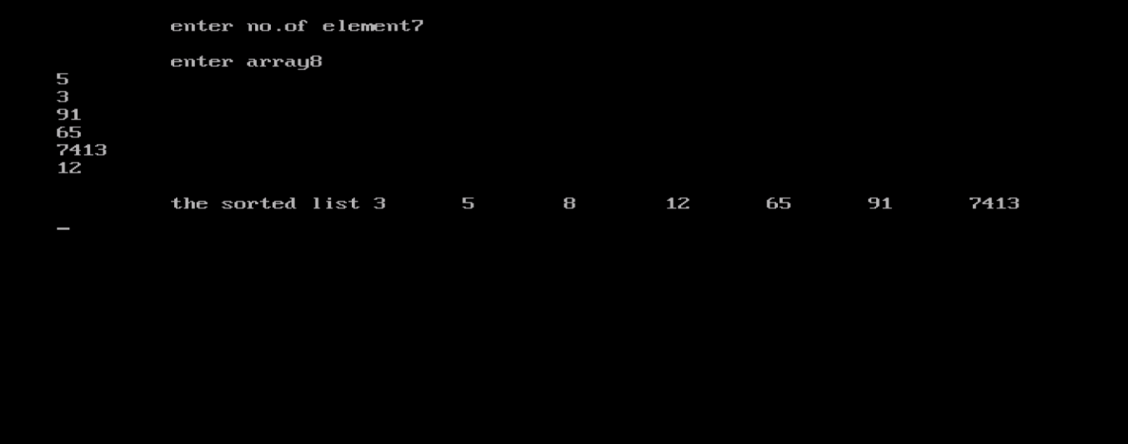

* **INSERtIOn sorting**

**#include<iostream.h>**

**#include<conio.h>**

**void main()**

**{**

**clrscr();**

**int list[100];**

**int i,n;**

**void insertion(int , int[]);**

**cout<<"\n\t enter size of the list";**

**cin>>n;**

**cout<<"\n\t enter list ";**

**for(i=0;i<n;i++)**

**{**

**cin>>list[i];**

**}**

**insertion (n,list);**

**getche();**

**}**

**void insertion (int n,int list[100])**

**{**

**int i,j,temp;**

**for (i=1;i<n;i++)**

**{**

**temp=list[i];**

**j=i-1;**

**while ((temp<list[j])&&(j>=0))**

**{**

**list[j+1]=list[j];**

**j=j-1;**

**}**

**list[j+1]=temp;**

**}**

**cout<<"\n\t the sorted list is "<<"\t";**

**for(i=0;i<n;i++)**

**cout<<list[i]<<"\t";**

**}**

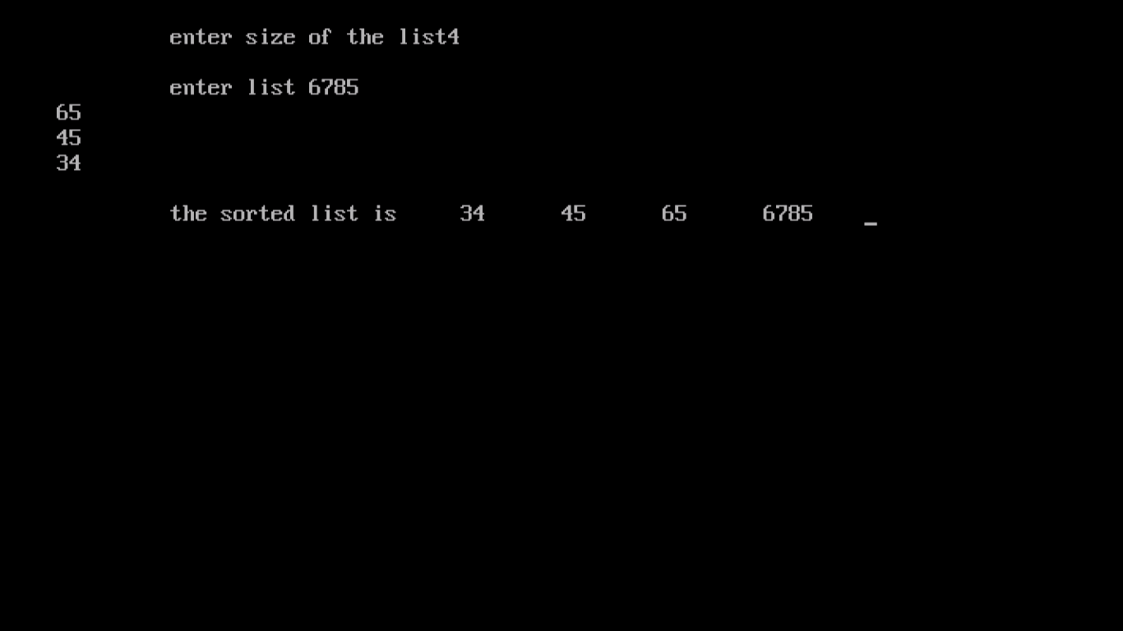

* **Selection sorting**

**#include<iostream.h>**

**#include<conio.h>**

**void main()**

**{**

**clrscr();**

**int i,k,n,a[100],temp,min;**

**void selection(int,int a[100]);**

**cout<<" enter the size";**

**cin>>n;**

**cout<<" enter elements";**

**for(i=0;i<n;i++)**

**cin>>a[i];**

**selection(n,a);**

**getche();**

**}**

**void selection(int n,int a[100])**

**{**

**int i,k,min,temp;**

**for(i=0;i<n;i++)**

**{**

**min=i;**

**for(k=i+1;k<n;k++)**

**{**

**if(a[min]>a[k])**

**min=k;**

**}**

**if(i!=min)**

**{**

**temp=a[i];**

**a[i]=a[min];**

**a[min]=temp;**

**}}**

**cout<<" the sorted list is";**

**for(i=0;i<n;i++)**

**cout<<"\t "<<a[i]<<"\t";**

**cout<<"\n";**

**}**

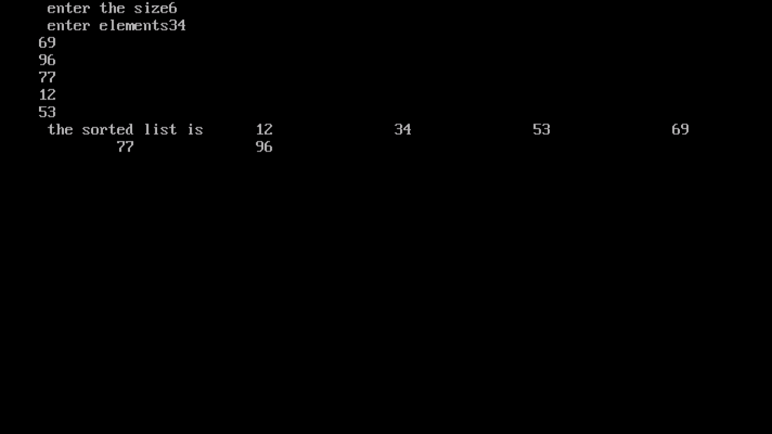

**searching**

* **Linear search**

**#include<conio.h>**

**#include<iostream.h>**

**void main()**

**{**

**clrscr();**

**int i,n,a[30],x;**

**void linear(int,int[],int);**

**cout<<"\n\t enter number of elements";**

**cin>>n;**

**cout<<"\n\t enter value of array";**

**for(i=0;i<n;i++)**

**cin>>a[i];**

**cout<<"\n \t enter the number want to search";**

**cin>>x;**

**linear(n,a,x);**

**getche();**

**}**

**void linear(int n,int a[30],int x)**

**{**

**int i,pos=-1;**

**for(i=0;i<n;i++)**

**{**

**if(a[i]==x)**

**pos=i;**

**}**

**if (pos==-1)**

**cout<<"\n\t not in the list";**

**else**

**cout<<"\n\t position at "<<++pos<<"position";**

**}**

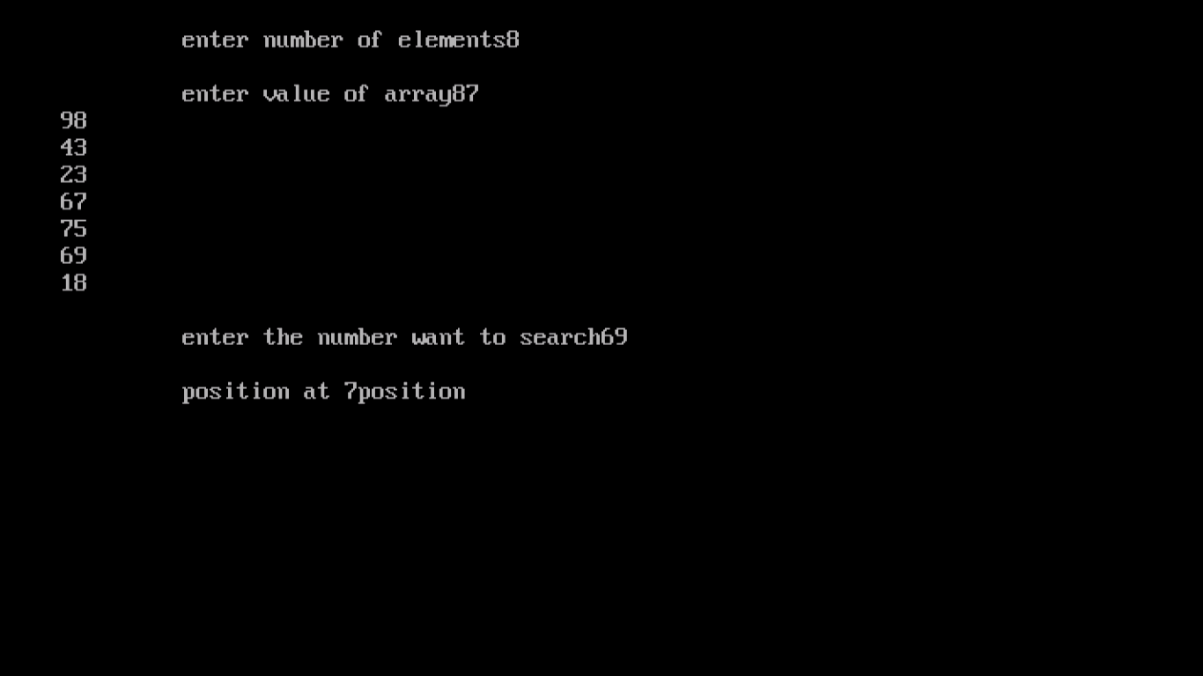

* **Binary search**

**#include<iostream.h>**

**#include<conio.h>**

**void main()**

**{clrscr();**

**int i,n,x,a[30];**

**void binary(int,int[],int);**

**cout<<"\t enter number of element";**

**cin>>n;**

**cout<<"\n enter array";**

**for(i=0;i<=n;i++)**

**cin>>a[i];**

**cout<<"\n enter element you need to search";**

**cin>>x;**

**binary(n,a,x);**

**getche();**

**}**

**void binary(int n,int a[30],int x)**

**{int f,l,pos,m;**

**f=0;**

**l=n-1;**

**pos=-1;**

**while(f<=l&& pos==-1)**

**{m=(f+l)/2;**

**if(a[m]==x){**

**pos=m; }**

**else if(a[m]>x){**

**l=m-1; pos=l; }**

**else if (a[m]<x) {**

**f=m+1; pos=f; }**

**}**

**if (pos==-1){**

**cout<<"\n not in the list"; }**

**else{**

**cout<<"\n present at "<<++pos<<" position";**

**} }**

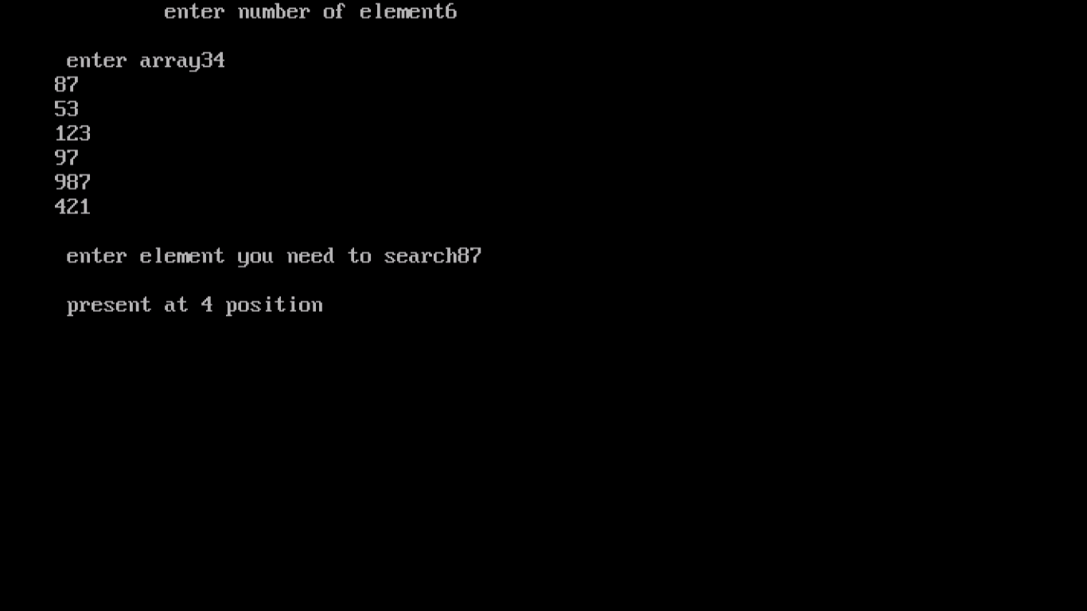

* **PROGRAM-1**

**#include<iostream.h>**

**#include<conio.h>**

**#include<process.h>**

**void display(int[],int);**

**void sort(int[],int);**

**void search(int[],int);**

**void main()**

**{**

**clrscr();**

**int n,i,ar[1000],r;**

**do**

**{**

**cout<<"1 add array"<<endl;**

**cout<<"2 display array"<<endl;**

**cout<<"3 sort array using insertion sort"<<endl;**

**cout<<"4 search for an element"<<endl;**

**cout<<"5 want to exit"<<endl;**

**cout<<"enter your choice";**

**cin>>r;**

**switch(r)**

**{**

**case 1:cout<<"enter size of the array";**

**cin>>n;**

**for(i=0;i<n;i++)**

**{**

**cout<<"enter the"<<i<<"element";**

**cin>>ar[i];**

**}**

**break;**

**case 2:display(ar,n);**

**break;**

**case 3:sort(ar,n);**

**break;**

**case 4:search(ar,n);**

**break;**

**}**

**}while(r!=5);**

**getche();**

**}**

**void display(int y[1000],int z)**

**{**

**int i;**

**cout<<"array is";**

**for(i=0;i<z;i++)**

**{**

**cout<<y[i]<<endl;**

**}**

**getche();**

**}**

**void sort(int y[1000],int z)**

**{**

**int i,j,temp;**

**for(i=0;i<z;i++)**

**{**

**temp=y[i];**

**j=i-1;**

**while((temp<y[j])&&(j>=0))**

**{**

**y[j+1]=y[j];**

**j=j-1;**

**}**

**y[j+1]=temp;**

**}**

**cout<<"\n the sorted list is";**

**for(i=0;i<=z;i++)**

**{**

**cout<<y[i]<<"\n";**

**}**

**getche();**

**}**

**void search(int y[1000],int z)**

**{**

**int pos,x,i;**

**int first,last,middle;**

**first=0;**

**pos=-1;**

**last=z-1;**

**cout<<"\n enter value to be searched";**

**cin>>x;**

**while((first<=last)&&(pos==-1))**

**{**

**middle=(first+last)/2;**

**if(y[middle]==x)**

**pos=middle;**

**else**

**if(y[middle]<x)**

**first=middle+1;**

**else**

**last=middle-1;**

**}**

**if(pos>-1)**

**cout<<"\n the position of elements:"<<++pos;**

**else**

**cout<<"unsuccessful search";**

**getche();**

**}**

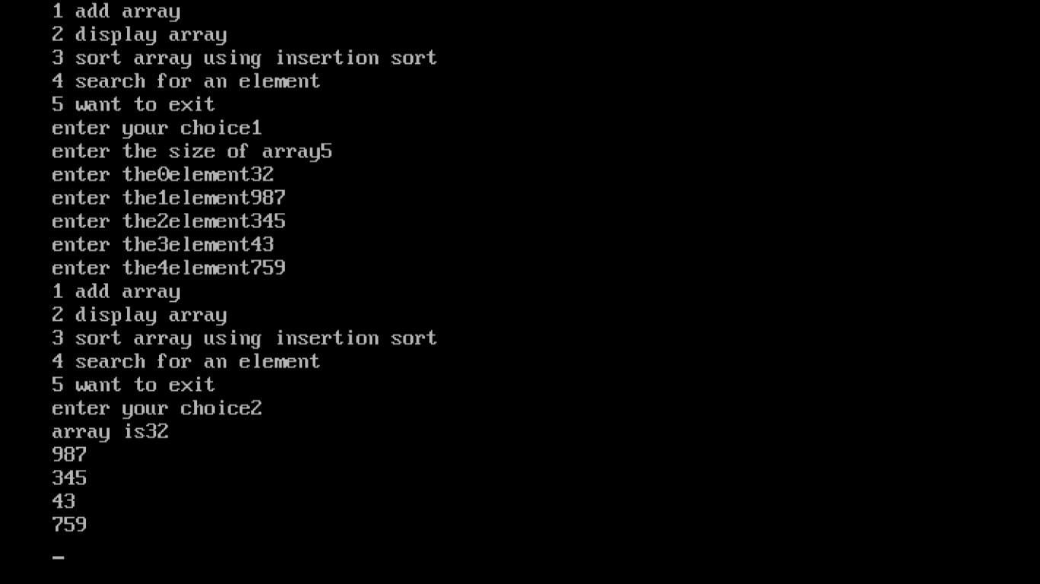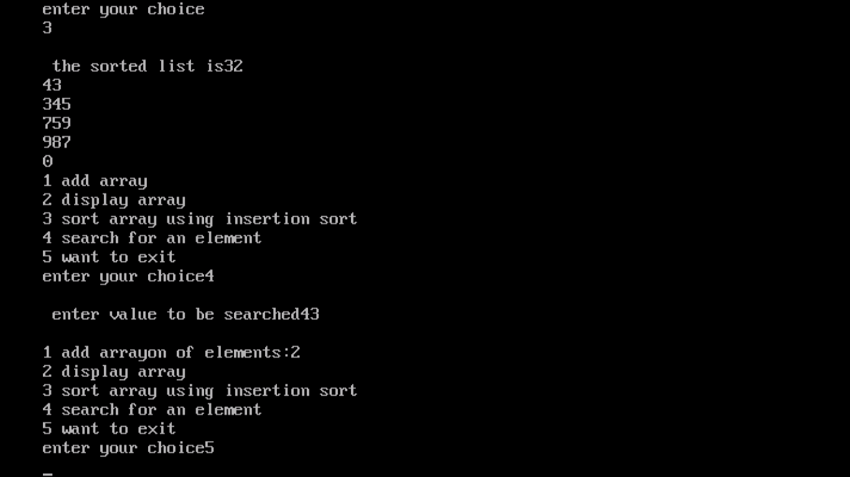

* **PROGRAM-2**

**#include<iostream.h>**

**#include<conio.h>**

**#include<process.h>**

**void display (int[],int);**

**void sort (int[],int);**

**void search (int[],int);**

**void main()**

**{**

**clrscr();**

**char ch;**

**int i,n,a[1000],r;**

**do**

**{**

**cout<<"\n1 add no. of elements"<<endl;**

**cout<<"\n2 display the elements"<<endl;**

**cout<<"\n3 sort elements using selection sort"<<endl;**

**cout<<"\n4 search for an element"<<endl;**

**cout<<"\n Enter your choice";**

**cin>>r;**

**switch(r)**

**{**

**case 1:cout<<"\n Enter size of an array";**

**cin>>n;**

**for(i=0;i<n;i++)**

**{**

**cout<<"\n Enter the" <<i<<"element \n\t";**

**cin>>a[i];**

**}**

**cout<<endl;**

**break;**

**case 2:display(a,n);**

**break;**

**case 3:sort(a,n);**

**break;**

**case 4:search(a,n);**

**break;**

**default:cout<<"\n\t wrong choice \n\t";**

**}**

**cout<<"\n do you want to continue? (y/n)\t";**

**cin>>ch;**

**}while(ch=='y'|| ch=='Y');**

**getche();**

**}**

**void display(int b[1000],int z)**

**{**

**int i;**

**for(i=0;i<z;i++)**

**{**

**cout<<"\n Enter array entered is \t"<<b[i];**

**}**

**getche();**

**}**

**void sort(int b[1000], int z)**

**{**

**int i,k,min,temp;**

**for (i=1; i<z-1; i++)**

**{**

**min=i;**

**for (k=i+1;k<z;k++)**

**{**

**if(b[min]>b[k])**

**min=k;**

**}**

**if(i!=min)**

**{**

**temp=b[i];**

**b[i]=b[min];**

**b[min]=temp;**

**}**

**}**

**cout<<"\n the sorted list is \t";**

**for(i=0;i<z;i++)**

**cout<<b[i]<<endl;**

**getche();**

**}**

**void search(int b[1000], int z)**

**{**

**int i, pos, x, f, l, m;**

**cout<<" \n\t Enter element to be searched\t";**

**cin>>x;**

**f=0;**

**l=z-1;**

**pos=-1;**

**while((f<=l) && (pos==-1))**

**{**

**m=(f+l)/2;**

**if(b[m]==x)**

**pos=m;**

**else if(b[m]>x)**

**l=m-1;**

**else if(b[m]<x)**

**f=m+1;**

**}**

**if(pos==-1)**

**cout<<"\n" <<x<<"is present at"<<++pos<<"position \t";**

**getche();**

**}**

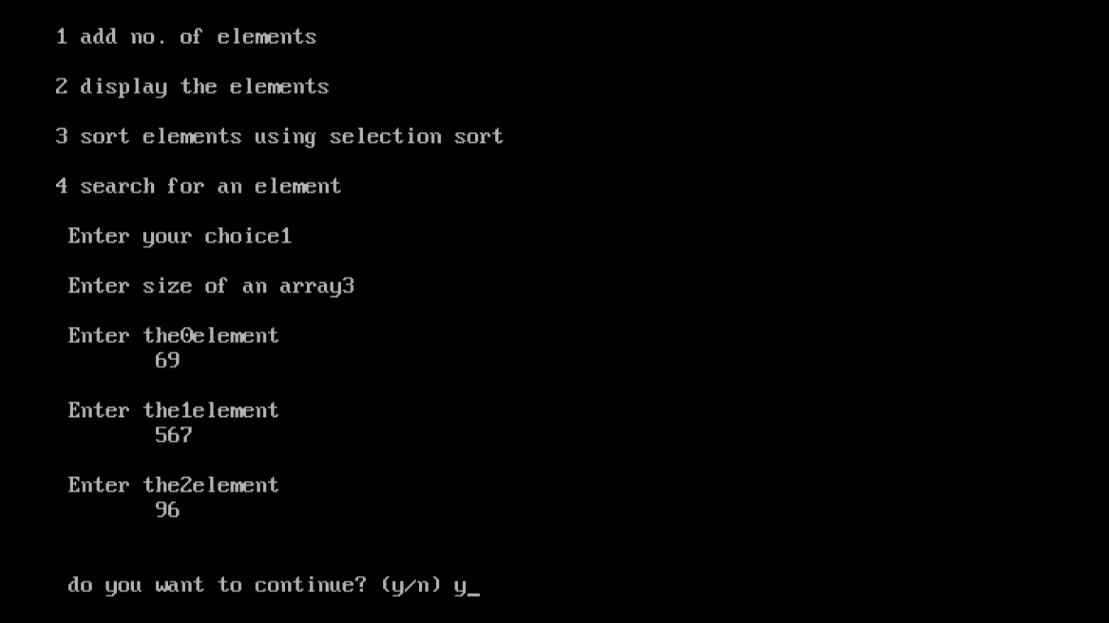

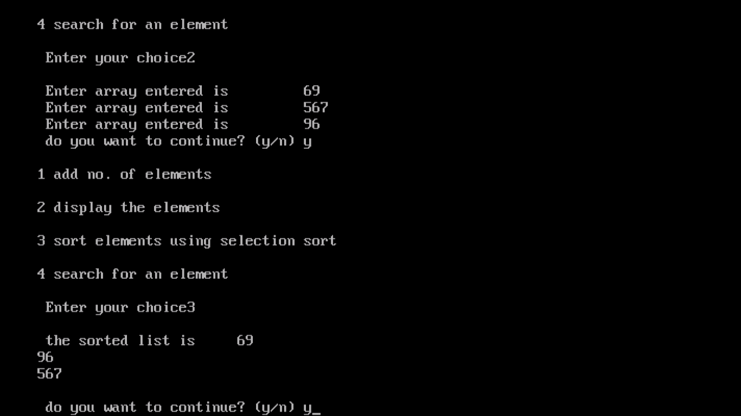

* **Matrix program**

**# include<iostream.h>**

**# include <conio.h>**

**void main()**

**{**

**int sum,i,j,r=0,c=0;**

**int a[10][10];**

**clrscr();**

**cout<<"Enter Number Of Rows & Columns Of 2D Array [ Matrix ]:";**

**cin>>r>>c ;**

**cout<<"Enter"<<r*c<<"Values for Array : ";**

**for(i=0;i<r;i++)**

**{**

**for (j=0;j<c;j++)**

**{**

**cin>>a[i][j];**

**}**

**}**

**cout<<“Values Of Array Are:";**

**for(i=0;i<r;i++)**

**{**

**cout<<"\n";**

**for(j=0;j<c;j++)**

**{**

**cout<<a[i][j];**

**}**

**}**

**sum=0;**

**if(r==c)**

**{**

**for(i=0; i<r; i++)**

**{**

**for(j=0; j<c; j++)**

**{**

**if(i+j==0 || i+j==2 || i+j==4)**

**{**

**sum=sum+a[i][j];**

**}**

**}**

**}**

**cout<<"\n Sum Of Diagonal Elements Of Array Is : "<<sum;**

**}**

**else**

**{**

**cout<<"\n Addition Is Not Possible";**

**}**

**getche();**

**}**

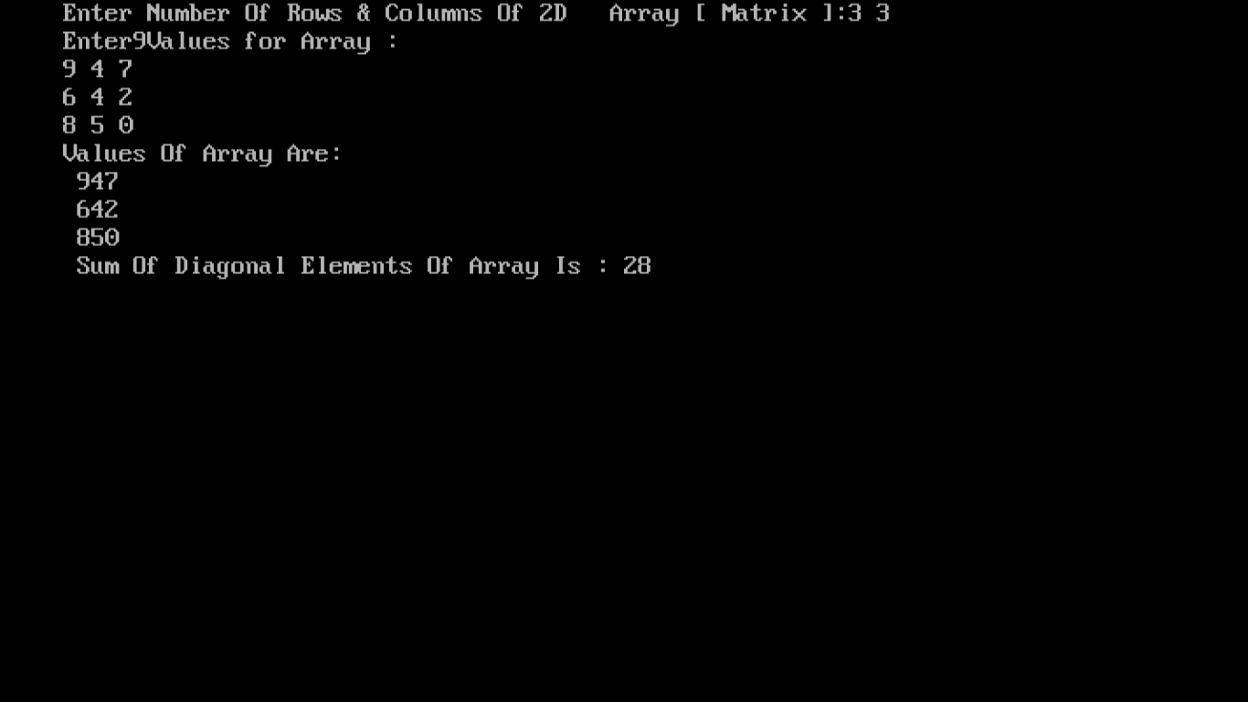

* **Program-3**

**#include<iostream.h>**

**#include<string.h>**

**#include<stdio.h>**

**#include<conio.h>**

**struct game**

**{**

**long pro;**

**char pname[10];**

**long points;**

**}s[10];**

**void main ()**

**{**

**clrscr();**

**int r,i,temp,min,pos,j,n;**

**char k[20];**

**do**

**{**

**cout<<"\n Main menu"<<endl;**

**cout<<"\n1 Enter elements"<<endl;**

**cout<<"\n2 sort using bubble sort"<<endl;**

**cout<<"\n3 Exit"<<endl;**

**cout<<"\n4 Enter your choice";**

**cin>>r;**

**switch(r)**

**{**

**case 1: cout<<"\n How many records do you want to enter";**

**cin>>n;**

**for(i=0;i<n;i++)**

**{**

**cout<<"\n Enter participant no.:";**

**cin>>s[i].pro;**

**cout<<"\n Enter participant name:";**

**gets(s[i].pname);**

**cout<<"\n Enter points";**

**cin>>s[i].points;**

**}**

**break;**

**case 2: cout<<"\n Bubble sorting";**

**for(i=0;i<n-1;i++)**

**{**

**for(j=0;j<n-1;j++)**

**{**

**if (s[j].points<s[j+1].points)**

**{**

**temp=s[j].points;**

**s[j].points=s[j+1].points;**

**s[j+1].points=temp;**

**strcpy(k,s[j].pname);**

**strcpy(s[j].pname,s[j+1].pname);**

**strcpy(s[j+1].pname,k);**

**temp=s[j].pro;**

**s[j].pro=s[j+1].pro;**

**s[j+1].pro=temp;**

**}}}**

**cout<<"\n The sorted list in descending order is:\n";**

**for(i=0;i<n;i++)**

**{**

**cout<<s[i].pro<<"\t"<<s[i].pname<<"\t"<<s[j].points<<"\n";**

**}**

**break;**

**}**

**}while(r!=3);**

**getche();**

**}**

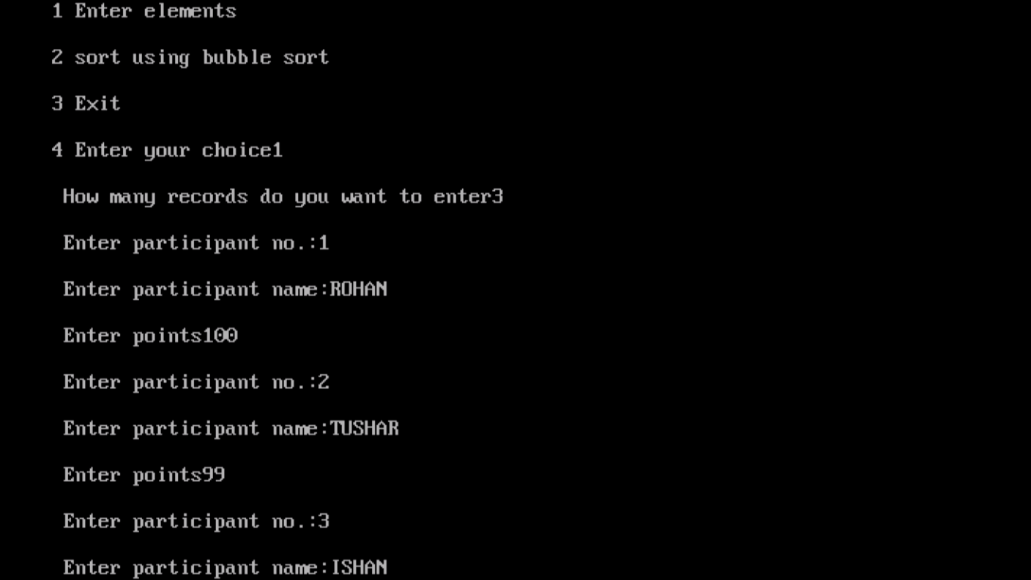

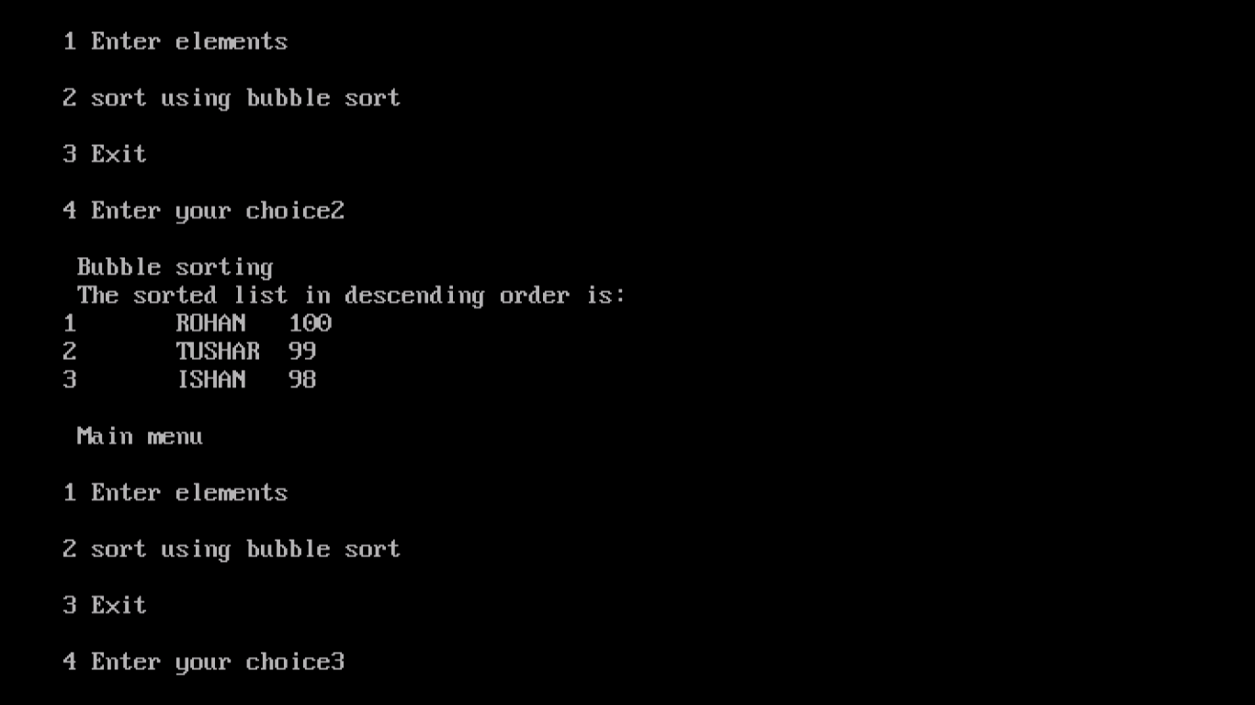

* **PROGRAM -4**

**#include<iostream.h>**

**#include<conio.h>**

**#include<stdio.h>**

**struct student**

**{**

**int roll;**

**char name[90];**

**float marks;**

**};**

**void add (int,student s[10]);**

**void bubble(int,student s[10]);**

**void selection(int,student s[10]);**

**void main()**

**{**

**clrscr();**

**int i,n,r;**

**char ch;**

**student s[10];**

**do**

**{**

**cout<<"\n 1.enter student detail";**

**cout<<"\n 2.sort student details in decending order by bubble sort";**

**cout<<"\n 3.sort student details in decending orderby selection sort";**

**cout<<"\n enter your choice(1-3)";**

**cin>>r;**

**switch(r)**

**{**

**case 1: cout<<" how many element do you want to enter ";**

**cin>>n;**

**add(n,s);**

**break;**

**case 2:bubble(n,s);**

**break;**

**case 3:selection(n,s);**

**break;**

**default : cout<<"wrong choce";**

**}**

**cout<<"\n do you want to continue? (y/n?) ";**

**cin>>ch;**

**}while(ch=='y' || ch=='Y');**

**getche();**

**}**

**void add(int x,student s[10])**

**{**

**int i;**

**for(i=0;i<x;i++)**

**{**

**cout<<"\n enter roll number";**

**cin>>s[i].roll;**

**cout<<"\n enter name";**

**gets(s[i].name);**

**cout<<"\n enter marks";**

**cin>>s[i].marks;**

**}**

**}**

**void bubble(int x,student s[10])**

**{**

**int i,j;**

**student temp;**

**for(i=0;i<x-1;i++)**

**{**

**for(j=0;j<x-1;j++)**

**{**

**if(s[j].roll<s[j+1].roll)**

**{**

**temp=s[j];**

**s[j]=s[j+1];**

**s[j+1]=temp;**

**}**

**}**

**}**

**for(i=0;i<n;i++)**

**{**

**cout<<"\n \n roll number \n \n "<<s[i].roll;**

**cout<<"\n \n name \n \n";**

**puts(s[i].name);**

**cout<<"\n \n marks \n \n"<<s[i].marks;**

**}**

**}**

**void selection (int x, student s[10])**

**{**

**int i,k,min;**

**student temp;**

**for(i=0;i<x-1;i++)**

**{**

**min=i;**

**for(k=i+1;k<x;k++)**

**{**

**if(s[min].roll<s[k].roll)**

**min=k;**

**}**

**if(i!=min)**

**{**

**temp=s[i];**

**s[i]=s[min];**

**s[min]=temp;**

**}**

**}**

**for(i=0;i<=n;i++)**

**{**

**cout<<"\n \n roll number \t "<<s[i].roll<<"\t";**

**cout<<"\n \n name \t ";**

**puts(s[i].name) ;**

**cout<<"\n \n marks \t "<<s[i].marks<<"\t";**

**cout<<endl;**

**}**

**}**

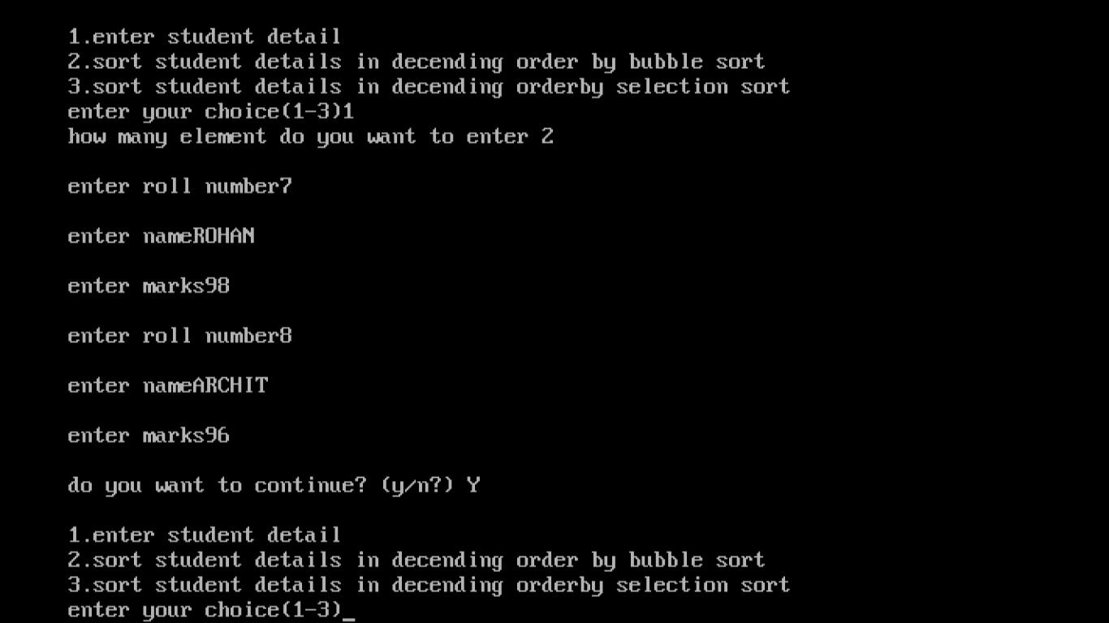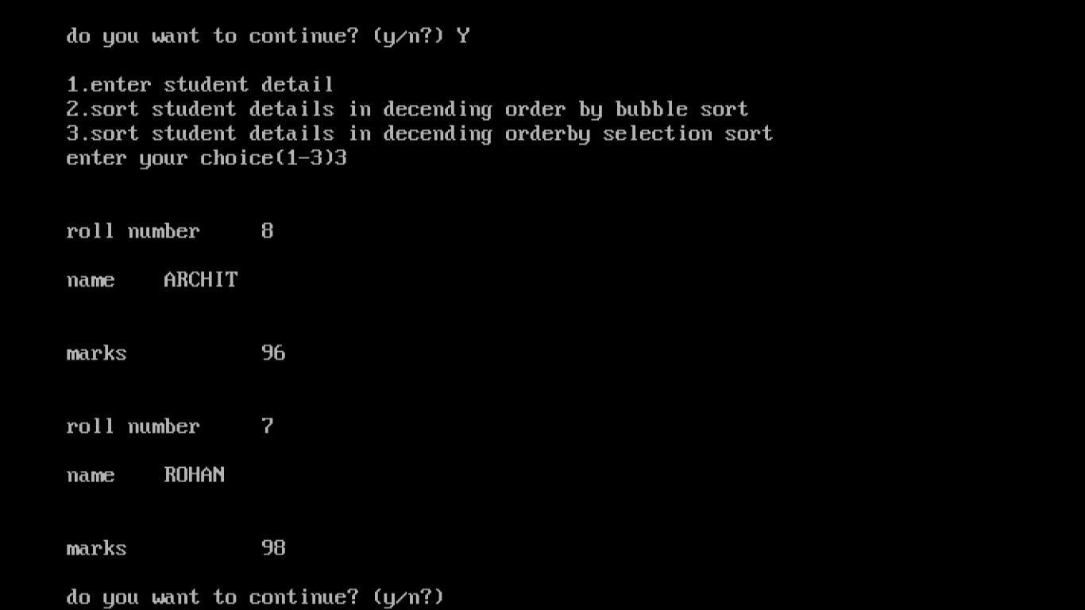

ACKNOWLEDMENT

I would like to express my special thanks of gratitude to my teacher MR. ARUN KHANNA who gave me the golden opportunity to do this wonderful project on the topic COMPUTER SCIENCE PROJECT which also helped me run a lot of programmes and I came to know about so many new things. Especially with my sir guidance I am able to complete this project. I am really thankful to him.  
signature-

Mr.Arun Khanna

H.O.D Computers

COMPUTER SCIENCE PROJECT

MADE BY-

ROHAN ARORA

* **Function overloading 1 :**

**#include<iostream.h>**

**#include<conio.h>**

**int area(int,int);**

**int area(int);**

**float area(float);**

**void main()**

**{**

**clrscr();**

**int l,b,or,s,or1;**

**float r,or2;**

**cout<<"enter L,B";**

**cin>>l>>b;**

**or=area(l,b);**

**cout<<"area of rectangle"<<or<<endl;**

**cout<<"enter side";**

**cin>>s;**

**or1=area(s);**

**cout<<"area of square"<<or1<<endl;**

**cout<<"enter radius";**

**cin>>r;**

**or2=area(r);**

**cout<<"area of circle"<<or2<<endl;**

**getche();**

**}**

**int area (int x,int y)**

**{**

**return(x*y);**

**}**

**int area(int z)**

**{**

**return(z*z);**

**}**

**float area(float t)**

**{**

**return(3.14*t*t);**

**}**

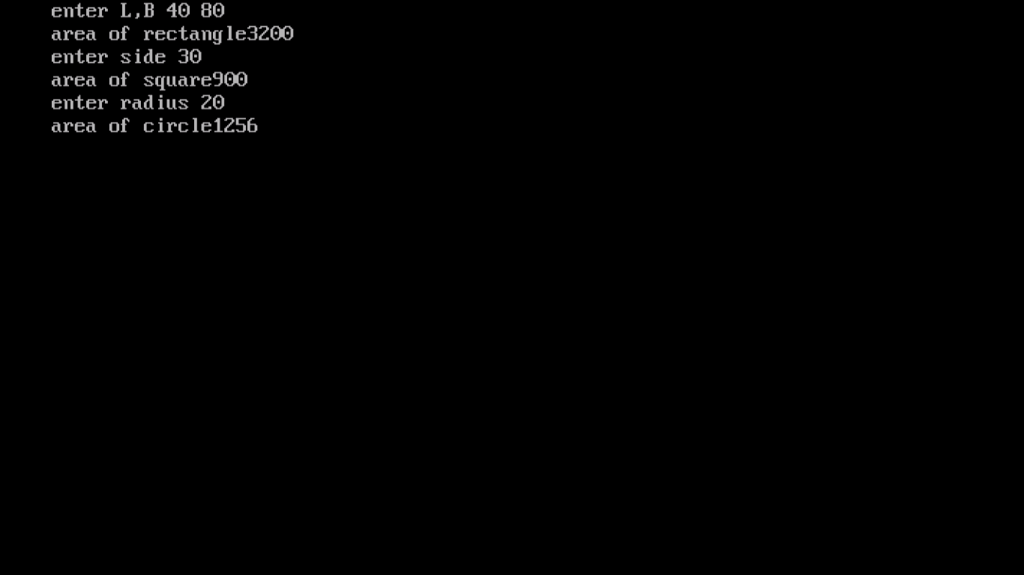

* **Function overloading 2 :**

**#include<iostream.h>**

**#include<conio.h>**

**int volume(int,int,int);**

**int volume(int);**

**float volume(float,float);**

**void main()**

**{**

**clrscr();**

**int l,b,h,v,s,v1;**

**float r,h1,v2;**

**cout<<"enter,l,b,h";**

**cin>>l>>b>>h;**

**v=volume(l,b,h);**

**cout<<"volume of cuboid"<<v<<endl;**

**cout<<"enter side";**

**cin>>s;**

**v1=volume(s);**

**cout<<"volume of cube"<<v1<< endl;**

**cout<<"enter r and h";**

**cin>>r>>h1;**

**v2=volume(r,h1);**

**cout<<"volume of cylinder"<<v2<<endl;**

**getche();**

**}**

**int volume(int x,int y,int z)**

**{**

**return(x*y*z);**

**}**

**int volume(int p)**

**{**

**return(p*p*p);**

**}**

**float volume(float t,float q)**

**{**

**return(3.14*t*t*q);**

**}**

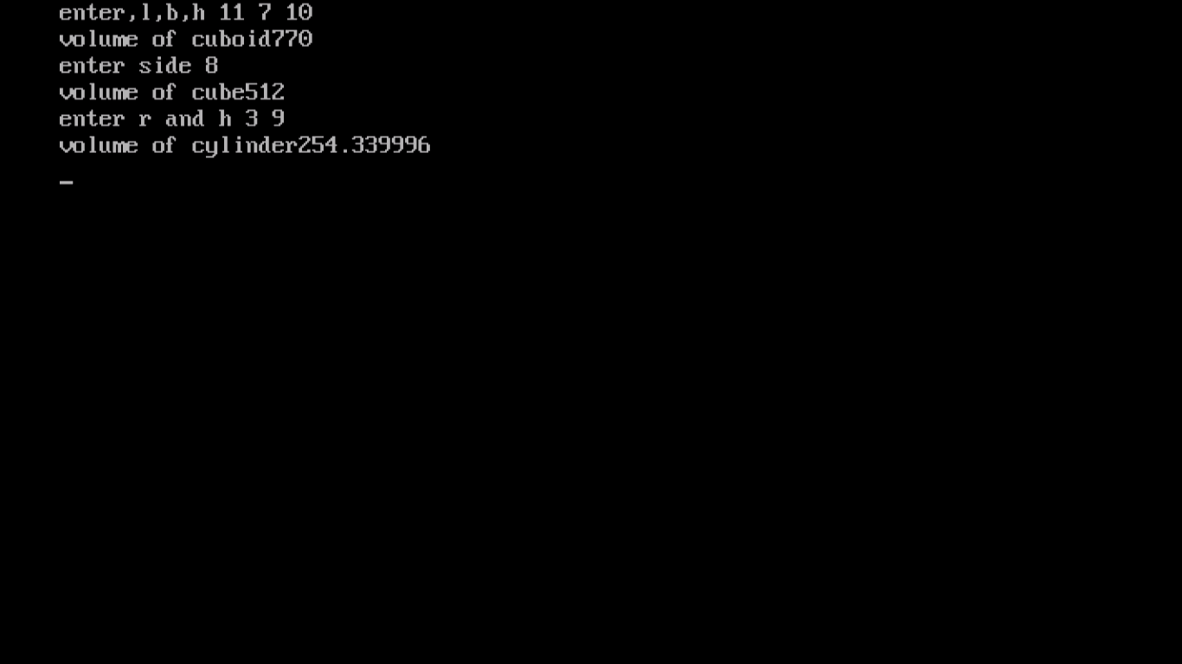

* **Constructors :**

**#include<iostream.h>**

**#include<conio.h>**

**#include<string.h>**

**class student**

**{**

**int rollno;**

**char name[20];**

**int age;**

**public:**

**student()**

**{**

**rollno=22;**

**strcpy(name,"Rohan");**

**age=18;**

**}**

**void putdata();**

**};**

**void student::putdata()**

**{**

**cout<<rollno<<"\t"<<name<<"\t"<<age<<endl;**

**}**

**void main()**

**{**

**clrscr();**

**student s;**

**s.putdata();**

**getche();**

**}**

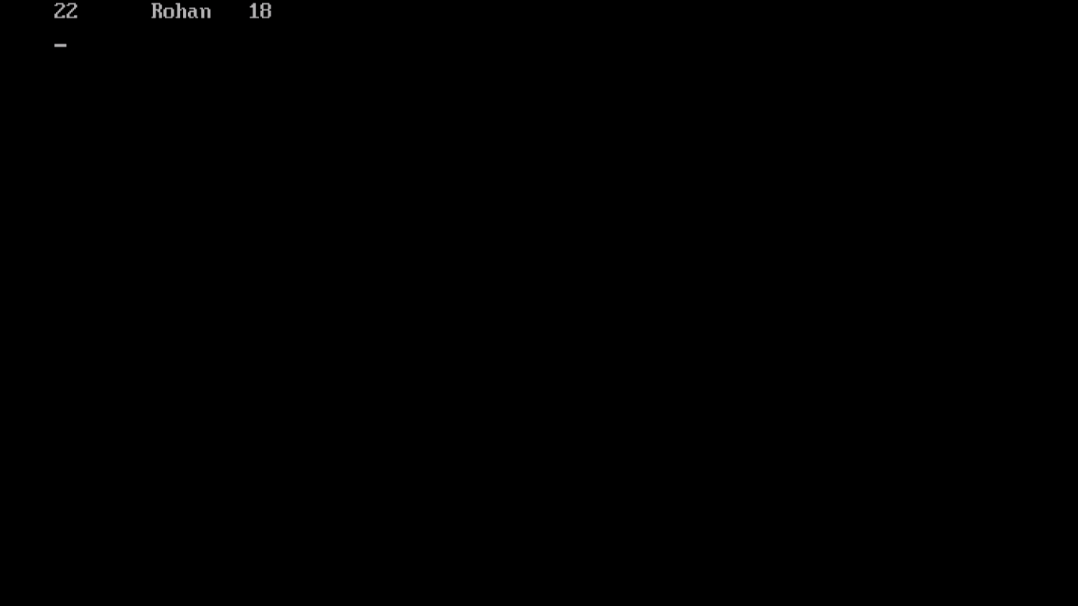

* **Destructors :**

**#include<iostream.h>**

**#include<conio.h>**

**#include<string.h>**

**class student**

**{**

**int rollno;**

**char name[20];**

**int age;**

**public:**

**student()**

**{**

**rollno=101;**

**strcpy (name,"ram");**

**age=12;**

**}**

**void putdata()**

**{**

**cout<<rollno<<"\t"<<name<<"\t"<<age;**

**}**

**~student()**

**{**

**cout<<"destructor called \n";**

**}**

**};**

**void main()**

**{**

**clrscr();**

**student s;**

**s.putdata();**

**getche();**

**}**

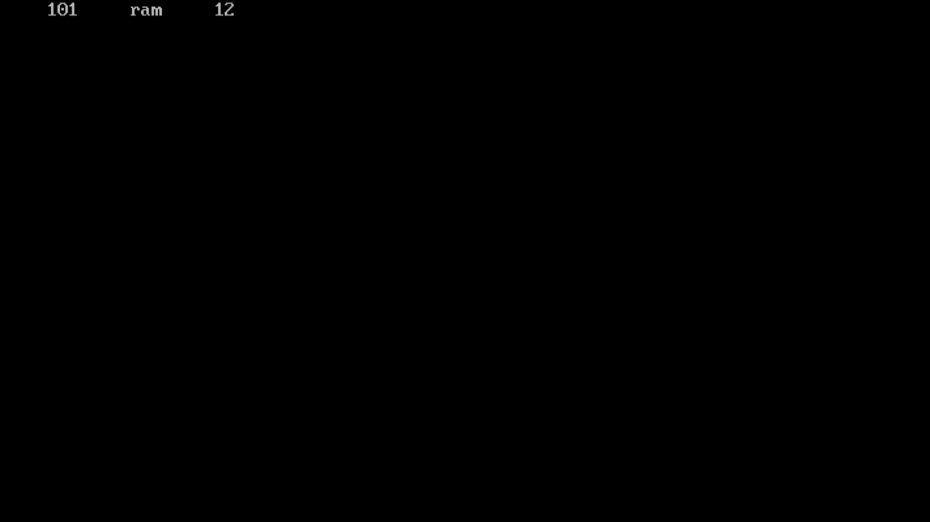

* **Classes and objects 1:**

**#include<iostream.h>**

**#include<conio.h>**

**#include<stdio.h>**

**class flight**

**{**

**long int flightnumber;**

**char destination[30];**

**float distance;**

**float fuel;**

**void calfuel();**

**public:**

**void FEEDINFO();**

**void showinfo();**

**};**

**void flight::calfuel()**

**{**

**if(distance<=1000)**

**fuel=500;**

**else if(distance>1000 && distance<=2000)**

**fuel=1100;**

**else if(distance>2000)**

**fuel=2200;**

**}**

**void flight::FEEDINFO()**

**{**

**cout<<"enter flightnumber"<<" ";**

**cin>>flightnumber;**

**cout<<"enter destination"<<" ";**

**gets(destination);**

**cout<<"enter distance"<<" ";**

**cin>>distance;**

**calfuel();**

**}**

**void flight::showinfo()**

**{**

**cout<<flightnumber<<"\t"<<destination<<"\t"<<distance<<"\t"<<fuel<<endl;**

**}**

**void main()**

**{**

**clrscr();**

**flight s;**

**s.FEEDINFO();**

**s.showinfo();**

**getche();**

**}**

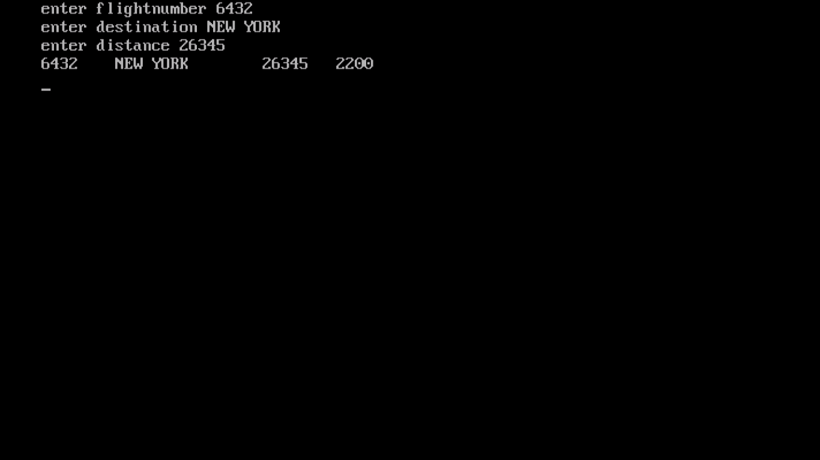

* **Classes and objects 2:**

**#include<iostream.h>**

**#include<conio.h>**

**#include<stdio.h>**

**#include<string.h>**

**class supply**

**{**

**int code;**

**char foodname[20];**

**char sticker[30];**

**char foodtype[20];**

**void gettype();**

**public:**

**void foodin();**

**void foodout();**

**};**

**void supply::gettype()**

**{**

**if(strcmp(sticker,"green")==0)**

**{**

**strcpy(foodtype,"vegetarian");**

**}**

**else if(strcmp(sticker,"yellow")==0)**

**{**

**strcpy(foodtype,"contain egg");**

**}**

**else if(strcmp(sticker,"red")==0)**

**{**

**strcpy(foodtype,"non-vegetarian");**

**}**

**}**

**void supply::foodin()**

**{**

**cout<<"enter code"<<" ";**

**cin>>code;**

**cout<<"enter foodname"<<" ";**

**gets(foodname);**

**cout<<"enter sticker"<<" ";**

**gets(sticker);**

**gettype();**

**}**

**void supply::foodout()**

**{**

**cout<<code<<"\t"<<foodname<<"\t"<<sticker<<"\t"<<foodtype;**

**}**

**void main()**

**{**

**clrscr();**

**supply s;**

**s.foodin();**

**s.foodout();**

**getche();**

**}**

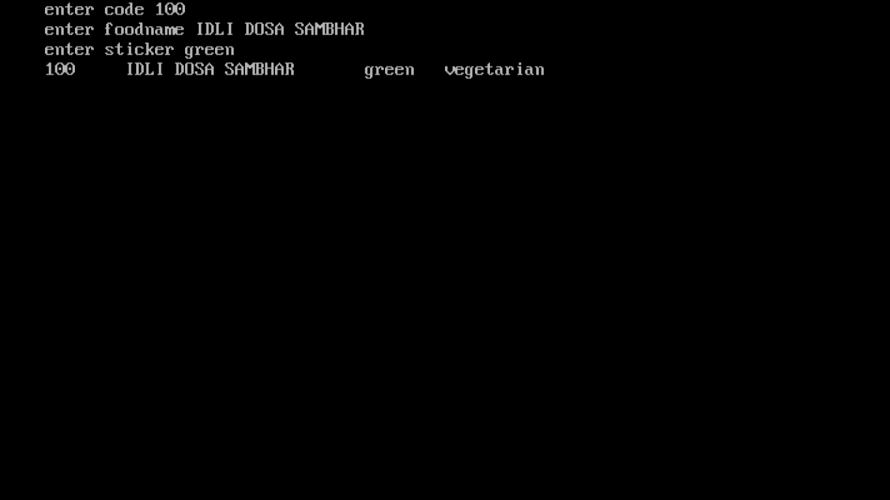

* **Single level inheritance:**

**#include<iostream.h>**

**#include<conio.h>**

**#include<stdio.h>**

**class student**

**{**

**int rollno;**

**char name[20];**

**int age;**

**public:**

**void getdata(void);**

**void putdata(void);**

**};**

**class marks:public student**

**{**

**int i,m[5];**

**public:**

**void getd(void);**

**void putd(void);**

**};**

**void student::getdata()**

**{**

**cout<<"enter roll no";**

**cin>>rollno;**

**cout<<"enter name";**

**gets(name);**

**cout<<"enter age";**

**cin>>age;**

**}**

**void student::putdata()**

**{**

**cout<<rollno<<"\t"<<name<<"\t"<<age;**

**}**

**void marks::getd()**

**{**

**for(i=0;i<5;i++)**

**{**

**cout<<"enter marks of 5 subjects";**

**cin>>m[i];**

**}**

**}**

**void marks::putd()**

**{**

**for(i=0;i<5;i++)**

**{**

**cout<<m[i]<<endl;**

**}**

**}**

**void main()**

**{**

**clrscr();**

**marks M;**

**M.getdata();**

**M.putdata();**

**M.getd();**

**M.putd();**

**getche();**

**}**

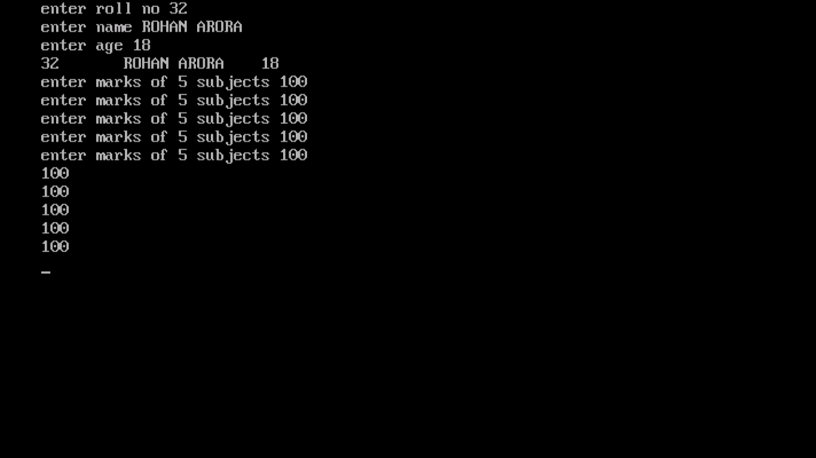

* **Multilevel inheritance:**

**#include<iostream.h>**

**#include<conio.h>**

**#include<stdio.h>**

**class student**

**{**

**int rollno;**

**char name[20];**

**int age;**

**public:**

**void getdata();**

**void putdata();**

**};**

**class marks:public student**

**{**

**protected:**

**int i,m[5];**

**public:**

**void getd();**

**void putd();**

**};**

**class grade:public marks**

**{**

**int s, avg;**

**public:**

**void calculate();**

**};**

**void student::getdata()**

**{**

**cout<<"enter roll no";**

**cin>>rollno;**

**cout<<"enter name";**

**gets(name);**

**cout<<"enter age";**

**cin>>age;**

**}**

**void student::putdata()**

**{**

**cout<<rollno<<"\t"<<name<<"\t"<<age<<endl;**

**}**

**void marks::getd()**

**{**

**for(i=0;i<5;i++)**

**{**

**cout<<"enter marks";**

**cin>>m[i];**

**}**

**}**

**void marks::putd()**

**{**

**for(i=0;i<5;i++)**

**{**

**cout<<m[i]<<endl;**

**}**

**}**

**void grade::calculate()**

**{**

**s=0;**

**for(i=0;i<5;i++)**

**s=s+m[i];**

**avg=s/5;**

**if(avg>=80)**

**cout<<"Grade A";**

**else if(avg>=60 && avg<80)**

**cout<<"Grade B";**

**else if(avg>=50 && avg<60)**

**cout<<"Grade C";**

**else if(avg<50)**

**cout<<"Grade D";**

**}**

**void main()**

**{**

**clrscr();**

**grade G;**

**G.getdata();**

**G.putdata();**

**G.getd();**

**G.putd();**

**G.calculate();**

**getche();**

**}**

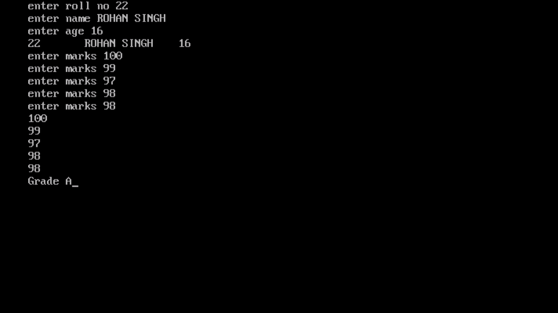

* **Multiple inheritance:**

**#include<iostream.h>**

**#include<conio.h>**

**#include<stdio.h>**

**class student**

**{**

**int rollno;**

**char name[20];**

**int age;**

**public:**

**void getdata();**

**void putdata();**

**};**

**class marks**

**{**

**protected:**

**int i,m[5];**

**public:**

**void getd();**

**void putd();**

**};**

**class grade:public student, public marks**

**{**

**int s,avg;**

**public:**

**void calculate();**

**};**

**void student::getdata()**

**{**

**cout<<" enter roll no ";**

**cin>>rollno;**

**cout<<" enter name ";**

**gets(name);**

**cout<<"enter age";**

**cin>>age;**

**}**

**void student:: putdata()**

**{**

**cout<<rollno<<"\t"<<name<<"\t"<<age<<endl;**

**}**

**void marks::getd()**

**{**

**for(i=0;i<5;i++)**

**{**

**cout<<"enter marks";**

**cin>>m[i];**

**}**

**}**

**void marks::putd()**

**{**

**for(i=0;i<5;i++)**

**{**

**cout<<m[i]<<endl;**

**}**

**}**

**void grade::calculate()**

**{**

**s=0;**

**for(i=0;i<5;i++)**

**{**

**s=s+m[i];**

**}**

**avg=s/5;**

**if(avg>=80)**

**cout<<"GRADE A";**

**else if(avg>=60 && avg<80)**

**cout<<"GRADE B";**

**else if(avg>=50 && avg<60)**

**cout<<"GRADE C";**

**else if(avg<50)**

**cout<<"GRADE D";**

**}**

**void main()**

**{**

**clrscr();**

**grade G;**

**G.getdata();**

**G.putdata();**

**G.getd();**

**G.putd();**

**G.calculate();**

**getche();**

**}**

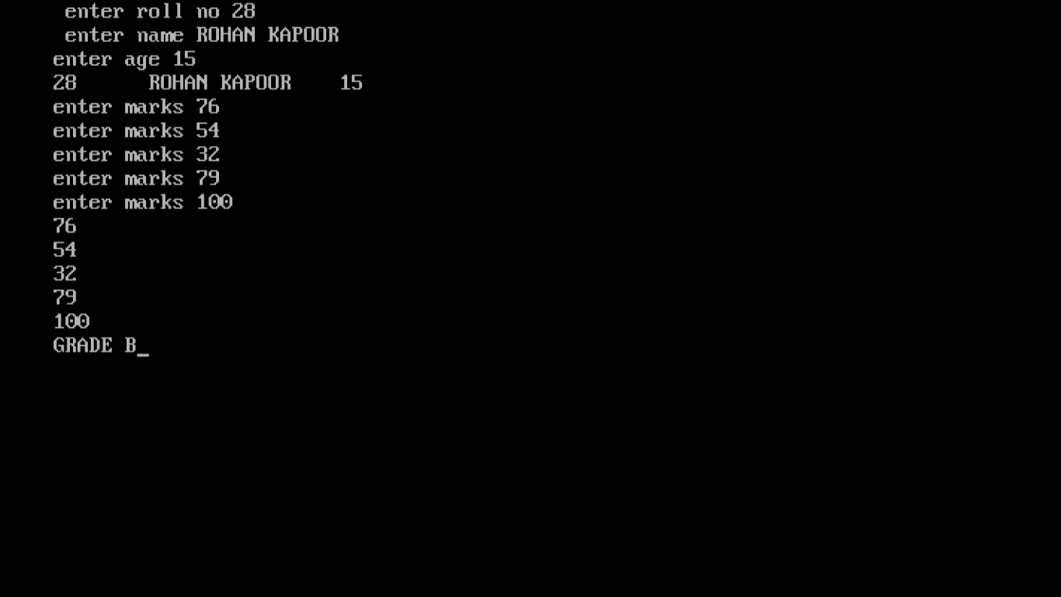

* **Hierarchical inheritance:**

**#include<iostream.h>**

**#include<conio.h>**

**#include<stdio.h>**

**class student**

**{**

**int rollno;**

**char name[20];**

**int age;**

**public:**

**void getdata();**

**void putdata();**

**};**

**class marks : public student**

**{**

**protected:**

**int i,m[5];**

**public:**

**void getd();**

**void putd();**

**};**

**class attendance : public student**

**{**

**int att;**

**public:**

**void check();**

**};**

**void student::getdata()**

**{**

**cout<<"enter rollno";**

**cin>>rollno;**

**cout<<"enter name";**

**gets(name);**

**cout<<"enter age";**

**cin>>age;**

**}**

**void student::putdata()**

**{**

**cout<<rollno<<"\t"<<name<<"\t"<<age<<endl;**

**}**

**void marks::getd()**

**{**

**for(i=0;i<5;i++)**

**{**

**cout<<"enter marks of 5 subjects";**

**cin>>m[i];**

**}**

**}**

**void marks::putd()**

**{**

**for(i=0;i<5;i++)**

**{**

**cout<<m[i]<<endl;**

**}**

**}**

**void attendance::check()**

**{**

**cout<<"enter attendance";**

**cin>>att;**

**if(att>=85)**

**cout<<"eligible";**

**else if(att<85)**

**cout<<"not eligible";**

**}**

**void main()**

**{**

**clrscr();**

**marks M;**

**attendance A;**

**M.getdata();**

**M.putdata();**

**M.getd();**

**M.putd();**

**A.check();**

**getche();**

**}**

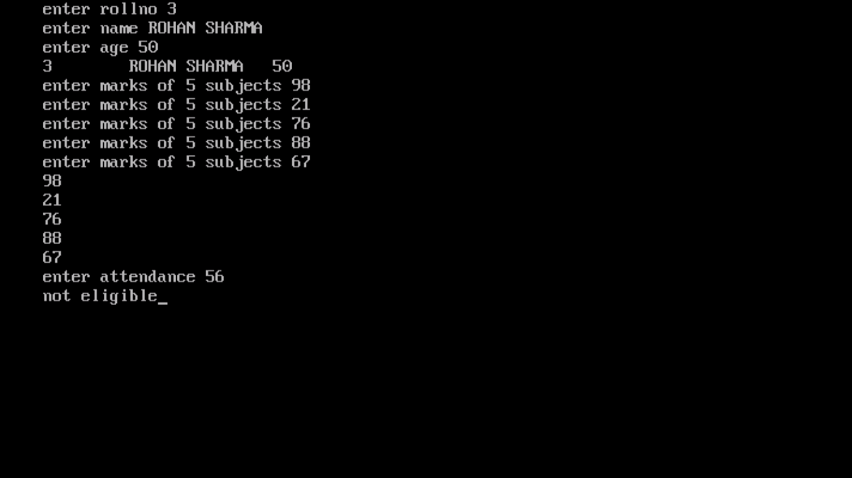

* **Hybrid inheritance:**

**#include<iostream.h>**

**#include<conio.h>**

**#include<stdio.h>**

**class student**

**{**

**int rollno;**

**char name[20];**

**int age;**

**public:**

**void getdata(void);**

**void putdata(void);**

**};**

**class marks:public student**

**{**

**protected:**

**int i,m[5];**

**public:**

**void getd();**

**void putd();**

**};**

**class attendance:public student**

**{**

**int att;**

**public:**

**void check();**

**};**

**class grade:public marks,public attendance**

**{**

**int s,avg;**

**public:**

**void calculate();**

**};**

**void student::getdata()**

**{**

**cout<<"enter rollno";**

**cin>>rollno;**

**cout<<"enter name";**

**gets(name);**

**cout<<"enter age";**

**cin >>age;**

**}**

**void student::putdata()**

**{**

**cout<<rollno<<"\t"<<name<<"\t"<<age<<endl;**

**}**

**void marks::getd()**

**{**

**for(i=0;i<5;i++)**

**{**

**cout<<"enter marks of 5 subjects";**

**cin>>m[i];**

**}**

**}**

**void marks::putd()**

**{**

**for(i=0;i<5;i++)**

**{**

**cout<<m[i]<<endl;**

**}**

**}**

**void attendance::check()**

**{**

**cout<<"enter attendance";**

**cin>>att;**

**if(att>=85)**

**cout<<"eligible"<<endl;**

**else if (att<85)**

**cout<<"not eligible"<<endl;**

**}**

**void grade::calculate()**

**{**

**s=0;**

**for(i=0;i<5;i++)**

**{**

**s=s+m[i];**

**}**

**avg=s/5;**

**if(avg>=80)**

**cout<<"grade A";**

**else if(avg>=60 && avg<80)**

**cout<<"grade B";**

**else if(avg>=50 && avg<60)**

**cout<<"grade C";**

**else if(avg<50)**

**cout<<"grade D";**

**}**

**void main()**

**{**

**clrscr();**

**student s;**

**grade g;**

**s.getdata();**

**s.putdata();**

**g.getd();**

**g.putd();**

**g.check();**

**g.calculate();**

**getche();**

**}**

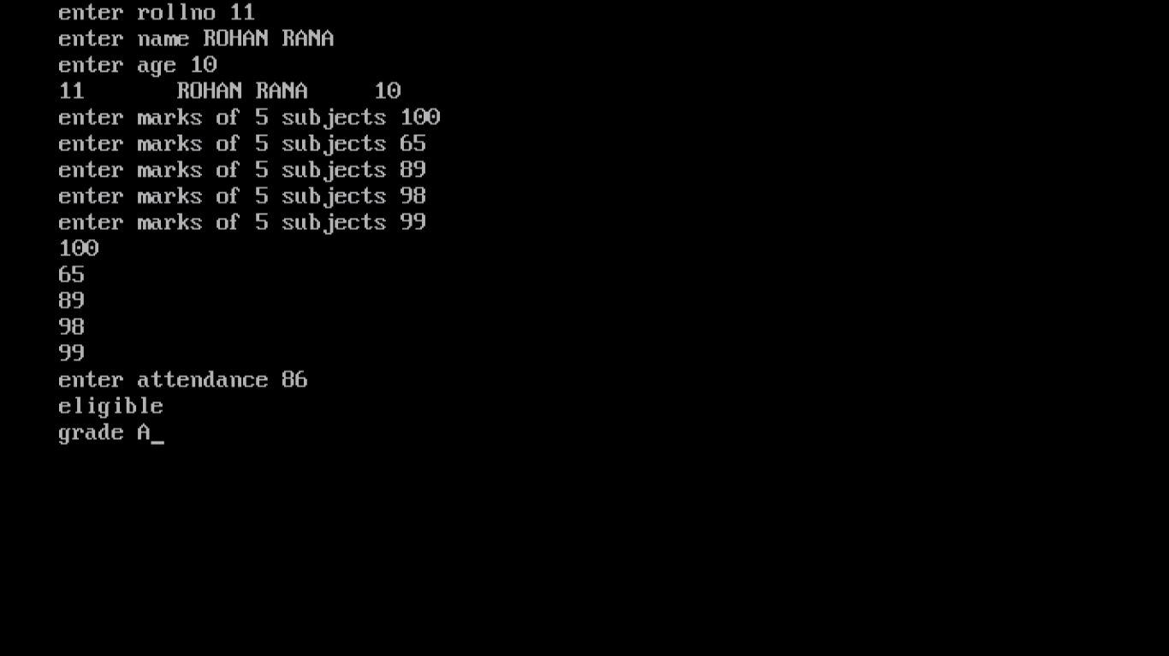

* **Text file 1:**

**#include<fstream.h>**

**#include<stdio.h>**

**#include<conio.h>**

**#include<ctype.h>**

**void main()**

**{**

**clrscr();**

**char str[20];**

**int i;**

**char ch;**

**char ch1;**

**int k=0;**

**int j=0;**

**ofstream afile("Rohan.txt");**

**gets(str);**

**for(i=0;str[i]!='\0';i++)**

**{**

**afile.put(str[i]);**

**}**

**afile.close();**

**ifstream bfile("Rohan.txt");**

**while(bfile)**

**{**

**bfile.get(ch);**

**cout<<ch;**

**cout<<endl;**

**}**

**bfile.close();**

**ifstream cfile("Rohan.txt");**

**while(cfile)**

**{**

**cfile.get(ch1);**

**if(isalpha(ch1))**

**k++;**

**else if(isdigit(ch1))**

**j++;**

**}**

**cout<<"total alphabets="<<k<<endl;**

**cout<<"total digits="<<j;**

**cfile.close();**

**getche();**

**}**

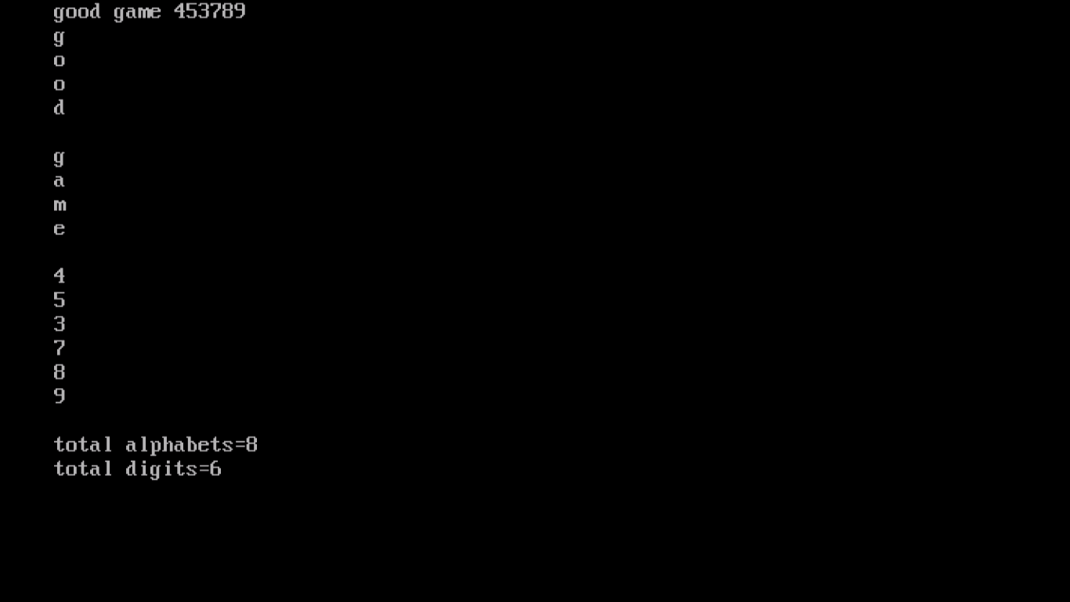

* **Text file 2:**

**#include<fstream.h>**

**#include<conio.h>**

**#include<string.h>**

**void main()**

**{**

**clrscr();**

**char str[20];**

**int i;**

**int n;**

**int k=0;**

**cout<<"enter the number of words to enter";**

**cin>>n;**

**ofstream afile("Lord.txt");**

**for (i=0;i<n;i++)**

**{**

**cout<<"enter word";**

**cin>>str;}**

**afile<<str<<"\n";**

**}**

**afile.close();**

**ifstream bfile("Lord.txt");**

**while(bfile)**

**{**

**bfile>>str;**

**cout<<str<<endl;**

**}**

**bfile.close();**

**ifstream cfile("Lord.txt");**

**while(cfile)**

**{**

**cfile>>str;**

**if(strcmpi(str,"the")==0)**

**k++;**

**}**

**cout<<"total occurences of word the"<<k;**

**cfile.close();**

**getche();**

**}**

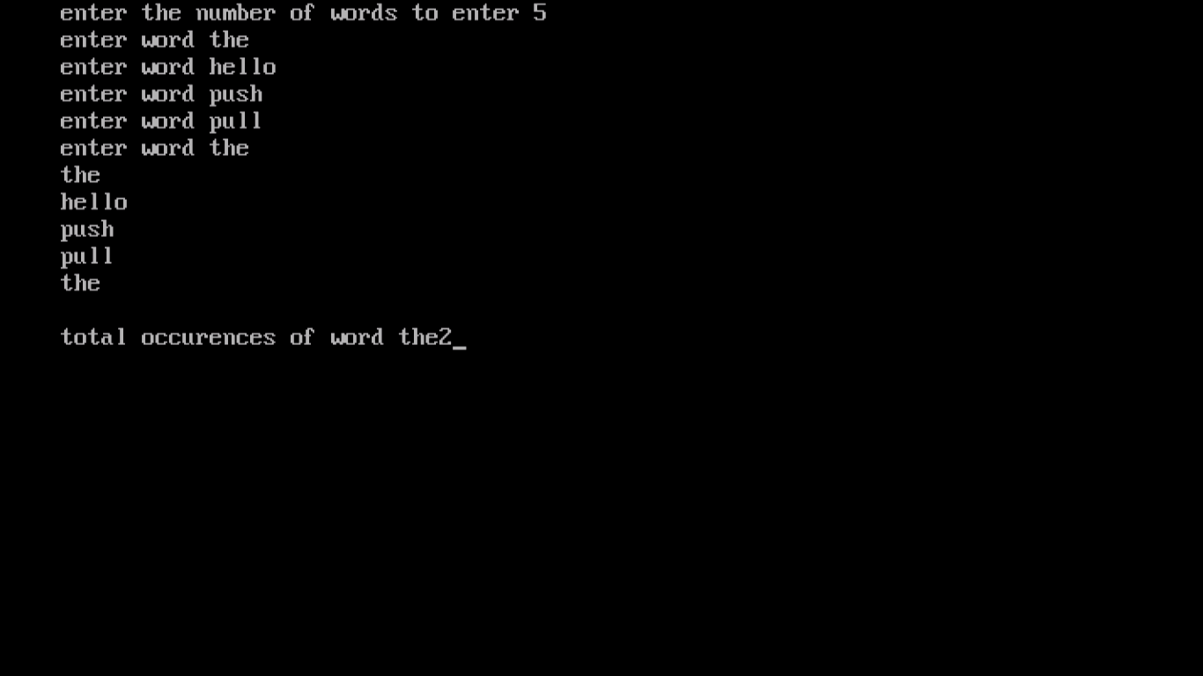

* **Text file 3:**

**#include<fstream.h>**

**#include<conio.h>**

**#include<stdio.h>**

**void main()**

**{**

**clrscr();**

**char str[80];**

**int i;**

**int j=0;**

**int n;**

**cout<<"enter total lines to enter";**

**cin>>n;**

**ofstream afile("line.txt");**

**for(i=0;i<n;i++)**

**{**

**cout<<"enter line";**

**gets(str);**

**afile<<str<<endl;**

**}**

**afile.close();**

**ifstream bfile("line.txt");**

**while(bfile)**

**{**

**bfile.getline(str,79);**

**cout<<str<<endl;**

**}**

**bfile.close();**

**ifstream cfile("line.txt");**

**while(cfile)**

**{**

**cfile.getline(str,79);**

**j++;**

**}**

**cout<<"total number of lines="<<j<<endl;**

**cfile.close();**

**getche();**

**}**

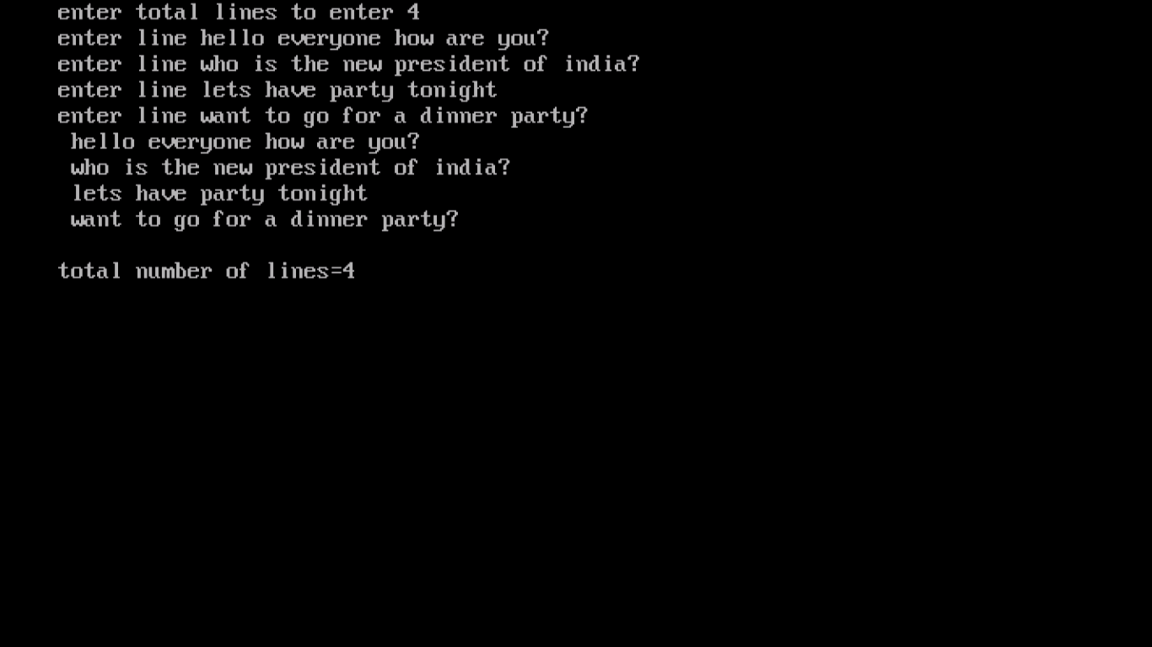

* **Text file 4:**

**#include<fstream.h>**

**#include<conio.h>**

**#include<stdio.h>**

**void main()**

**{**

**clrscr();**

**char str[30];**

**int j;**

**char ch;**

**int i=0;**

**ofstream afile("Ram.txt");**

**gets(str);**

**for(j=0;str[j]!='\0';j++)**

**{**

**afile.put(str[j]);**

**}**

**afile.close();**

**ifstream bfile("Ram.txt");**

**while (bfile)**

**{**

**bfile.get(ch);**

**if(ch==' ')**

**i++;**

**}**

**cout<<"total spaces"<<i;**

**bfile.close();**

**getche();**

**}**

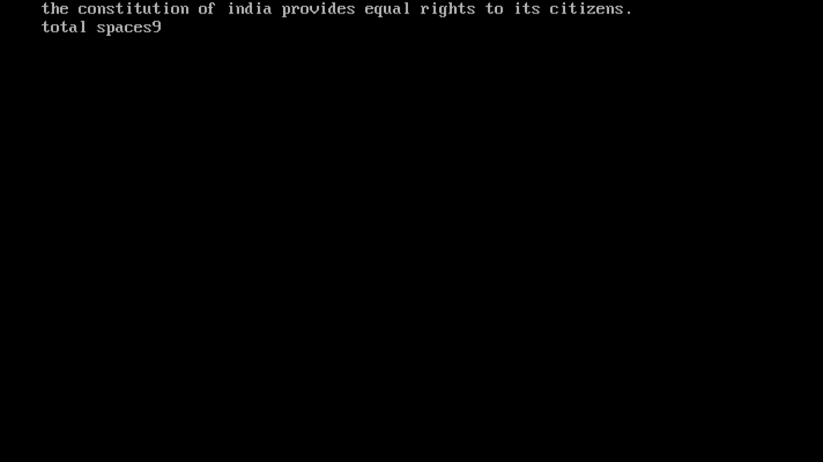

* **Text file 5:**

**#include<fstream.h>**

**#include<conio.h>**

**#include<string.h>**

**void main()**

**{**

**clrscr();**

**char str[20];**

**int i;**

**int n;**

**int k=0;**

**int j=0;**

**cout<<"enter the totol no. of words you want to store"<<" ";**

**cin>>n;**

**ofstream afile("good.txt");**

**for(i=0;i<n;i++)**

**{**

**cout<<"enter word"<<" ";**

**cin>>str;**

**afile<<str<<" ";**

**}**

**afile.close();**

**ifstream bfile("good.txt");**

**while(bfile)**

**{**

**bfile>>str;**

**if(strcmpi(str,"me")==0)**

**{**

**k++;**

**}**

**else if(strcmpi(str,"my")==0)**

**{**

**j++;**

**}**

**}**

**cout<<"total occurences of me"<<" "<<k<<endl;**

**cout<<"total occurences of my"<<" "<<j;**

**bfile.close();**

**getche();**

**}**

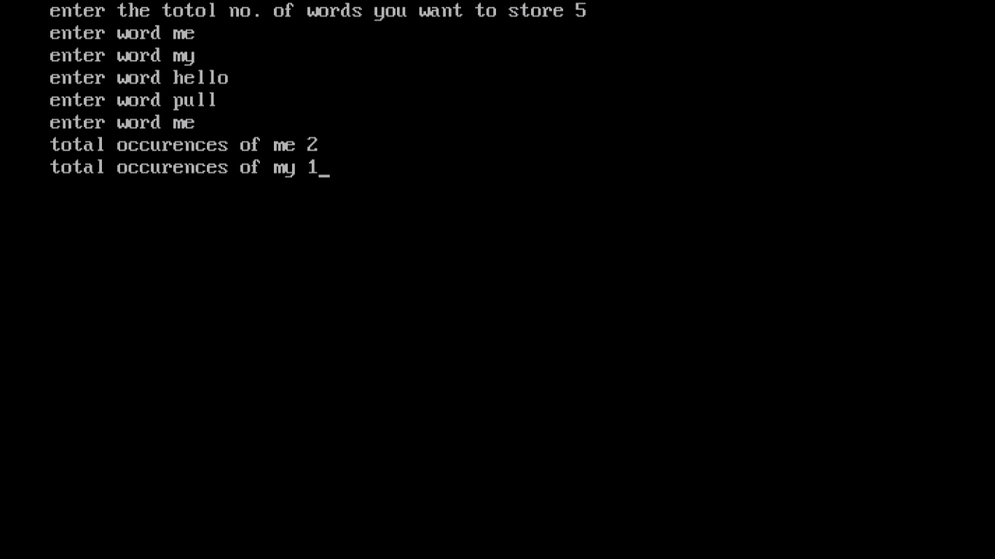

* **Text file 6:**

**#include<fstream.h>**

**#include<conio.h>**

**#include<stdio.h>**

**#include<string.h>**

**void main()**

**{**

**clrscr();**

**char str[80];**

**int i;**

**int k;**

**int j=0;**

**int n;**

**cout<<"enter total lines to enter";**

**cin>>n;**

**ofstream afile("hello.txt");**

**for(i=0;i<n;i++)**

**{**

**cout<<"enter line";**

**gets(str);**

**afile<<str<<endl;**

**}**

**afile.close();**

**ifstream bfile("hello.txt");**

**while(bfile)**

**{**

**bfile.getline(str,79);**

**cout<<str<<endl;**

**}**

**bfile.close();**

**ifstream cfile("hello.txt");**

**while(cfile)**

**{**

**cfile.getline(str,79);**

**for(i=0;i<n;i++)**

**{**

**for(k=0;str[k]!='0';k++)**

**{**

**if(strcmp(str,"a")==0)**

**j++;**

**}**

**}**

**}**

**cout<<"total times a occurs"<<" "<<j;**

**cfile.close();**

**getche();**

**}**

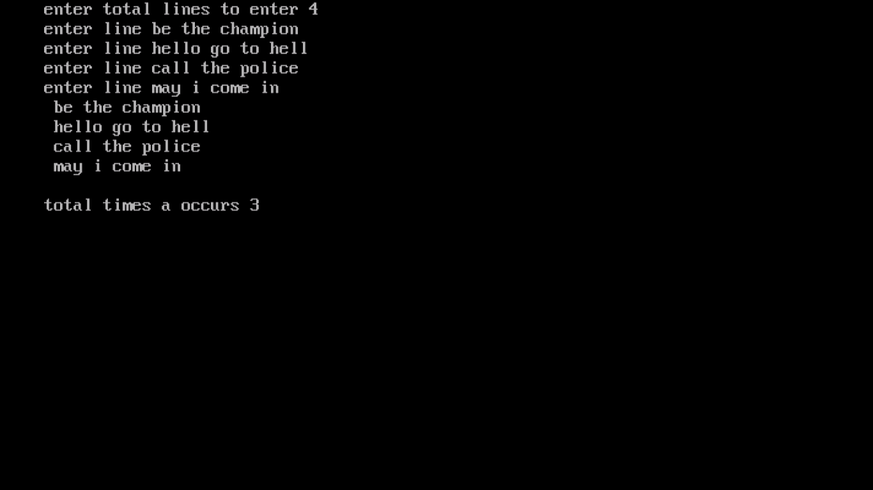

* **Binary text file 1:**

**#include<fstream.h>**

**#include<stdio.h>**

**#include<conio.h>**

**struct student**

**{**

**int rollno;**

**char name[20];**

**int age;**

**}s;**

**void main()**

**{**

**clrscr();**

**ofstream afile("stu.dat",ios::binary);**

**cout<<"enter roll no.";**

**cin>>s.rollno;**

**cout<<"enter students name";**

**gets(s.name);**

**cout<<"enter age";**

**cin>>s.age;**

**afile.write((char*) & s, sizeof(s));**

**afile.close();**

**getche();**

**}**

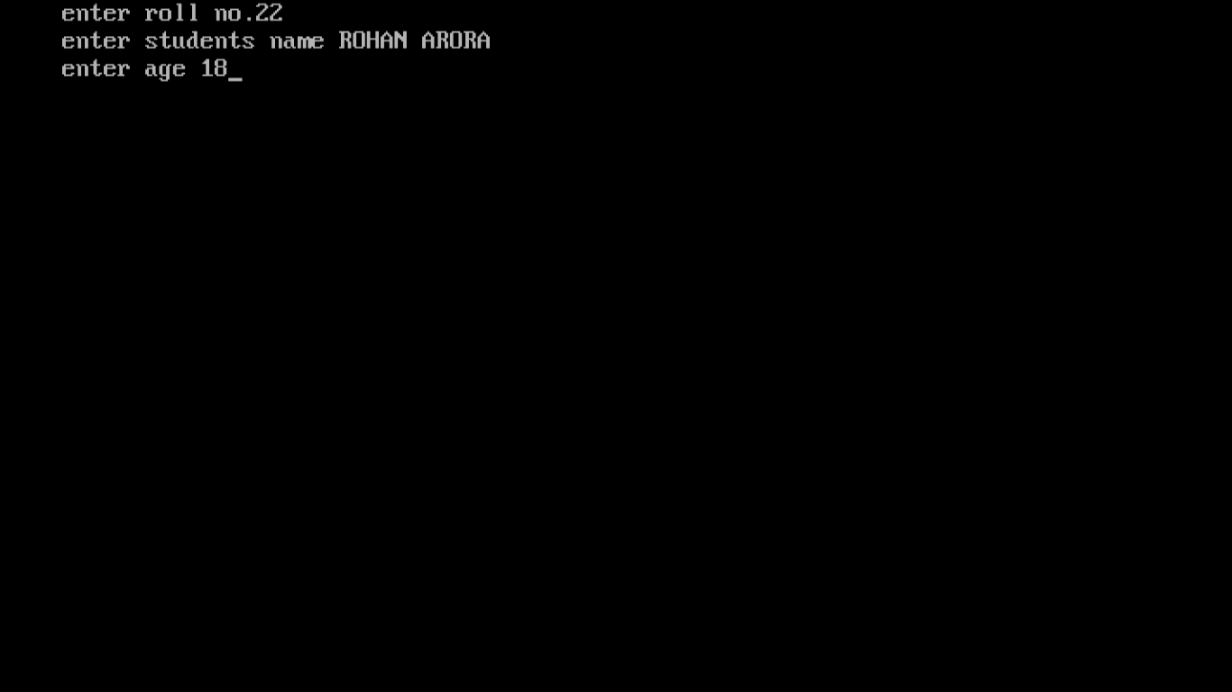

* **Binary text file 2:**

**#include<fstream.h>**

**#include<conio.h>**

**struct student**

**{**

**int rollno;**

**char name[20];**

**int age;**

**}s;**

**void main()**

**{**

**clrscr();**

**ifstream afile("stu.dat",ios::binary);**

**while(afile.read((char*) & s, sizeof(s)))**

**{**

**cout<<s.rollno<<"\t"<<s.name<<"\t"<<s.age<<endl;**

**}**

**afile.close();**

**getche();**

**}**

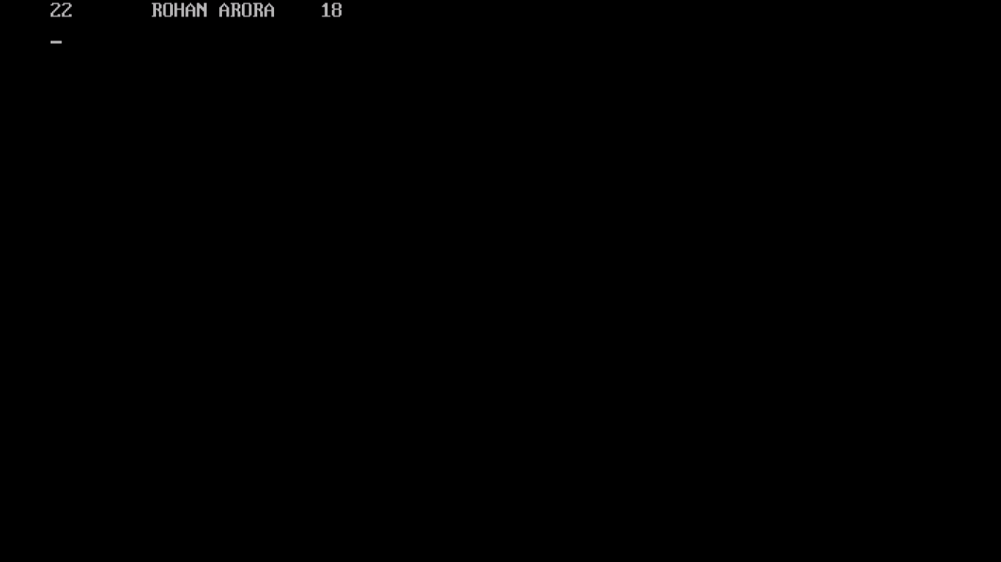

* **Binary text file 3:**

**#include<fstream.h>**

**#include<conio.h>**

**#include<stdio.h>**

**class student**

**{**

**int rollno;**

**char name[20];**

**int age;**

**public:**

**void getdata(void);**

**void putdata(void);**

**};**

**void student::getdata()**

**{**

**cout<<"enter roll no";**

**cin>>rollno;**

**cout<<"enter name";**

**gets(name);**

**cout<<"enter age";**

**cin>>age;**

**}**

**void student::putdata()**

**{**

**cout<<rollno<<"\t"<<name<<"\t"<<age<<endl;**

**}**

**void main()**

**{**

**student s;**

**ofstream afile("stu.dat",ios::binary);**

**s.getdata();**

**afile.write((char*) & s,sizeof(s));**

**afile.close();**

**ifstream bfile("stu.dat",ios::binary);**

**while(bfile.read((char*) & s, sizeof(s)))**

**{**

**s.putdata();**

**}**

**bfile.close();**

**getche();**

**}**

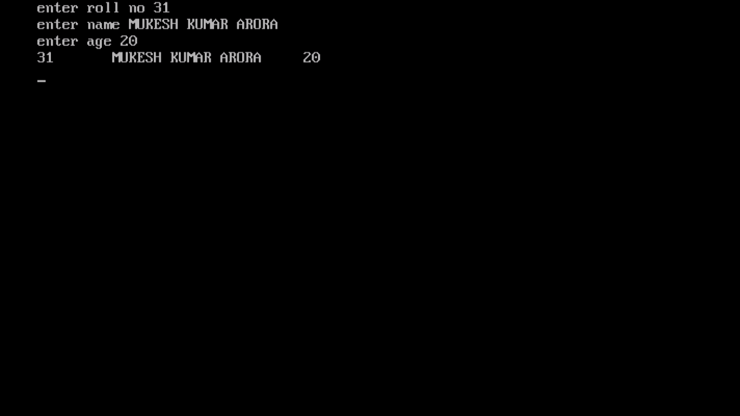

* **Menu driven 1:**

**#include<fstream.h>**

**#include<conio.h>**

**#include<stdio.h>**

**class student**

**{**

**int rollno;**

**char name[20];**

**int age;**

**public:**

**void getdata(void);**

**void putdata(void);**

**int getroll();**

**};**

**void student::getdata()**

**{**

**cout<<"enter roll no";**

**cin>>rollno;**

**cout<<"enter name";**

**gets(name);**

**cout<<"enter age";**

**cin>>age;**

**}**

**void student::putdata()**

**{**

**cout<<rollno<<"\t"<<name<<"\t"<<age<<endl;**

**}**

**int student::getroll()**

**{**

**return(rollno);**

**}**

**student s;**

**void main()**

**{**

**clrscr();**

**void enterfile();**

**void displayfile();**

**void search();**

**void modify();**

**void Delete();**

**int c;**

**do**

**{**

**cout<<"main menu\n";**

**cout<<"1.add student's record \n";**

**cout<<"2.display student's record\n";**

**cout<<"3.search a record\n";**

**cout<<"4.modify a record\n";**

**cout<<"5.delete a record\n";**

**cout<<"6.want to exit?\n";**

**cout<<"enter your choice";**

**cin>>c;**

**switch(c)**

**{**

**case 1:enterfile();**

**break;**

**case 2:displayfile();**

**break;**

**case 3:search();**

**break;**

**case 4:modify();**

**break;**

**case 5:Delete();**

**break;**

**}**

**}while(c!=6);**

**cout<<endl;**

**getche();**

**}**

**void enterfile()**

**{**

**ofstream afile("stu.dat",ios::binary|ios::app );**

**s.getdata();**

**afile.write((char*)& s, sizeof(s));**

**afile.close();**

**cout<<endl;**

**getche();**

**}**

**void displayfile()**

**{**

**ifstream bfile("stu.dat",ios::binary);**

**while(bfile.read((char*)& s, sizeof(s)))**

**{**

**s.putdata();**

**}**

**bfile.close();**

**cout<<endl;**

**getche();**

**}**

**void search()**

**{**

**int p=-1,z;**

**ifstream cfile("stu.dat",ios::binary);**

**cout<<"please enter rollno to be searched:\n";**

**cin>>z;**

**while(cfile.read((char*)& s,sizeof(s)))**

**{**

**if(s.getroll()==z)**

**{**

**s.putdata();**

**p++;**

**}**

**}**

**if(p==-1)**

**cout<<"sorry!record not found\n";**

**cout<<endl;**

**cfile.close();**

**getche();**

**}**

**void modify()**

**{**

**int g=-1,a=0,t;**

**cout<<"please enter the rollno.to be modified:\n";**

**cin>>t;**

**fstream dfile("stu.dat",ios::in|ios::binary|ios::out );**

**while(dfile.read((char*)& s,sizeof(s)))**

**{**

**a++;**

**if(s.getroll()==t)**

**{**

**s.getdata();**

**dfile.seekp((a-1)*sizeof(s),ios::beg);**

**dfile.write((char*)& s, sizeof(s));**

**g++;**

**}**

**}**

**if(g==-1)**

**cout<<"sorry record not found\n";**

**dfile.close();**

**getche();**

**}**

**void Delete()**

**{**

**int b;**

**ifstream efile("stu.dat",ios::binary);**

**ofstream ffile("temp.dat",ios::binary);**

**cout<<"please enter the roll no to be deleted\n";**

**cin>>b;**

**while(efile.read((char*)& s,sizeof(s)))**

**{**

**if(s.getroll()!=b)**

**{**

**ffile.write((char*)& s,sizeof(s));**

**}**

**}**

**remove("stu.dat");**

**rename("temp.dat","stu.dat");**

**efile.close();**

**ffile.close();**

**cout<<endl;**

**getche();**

**}**

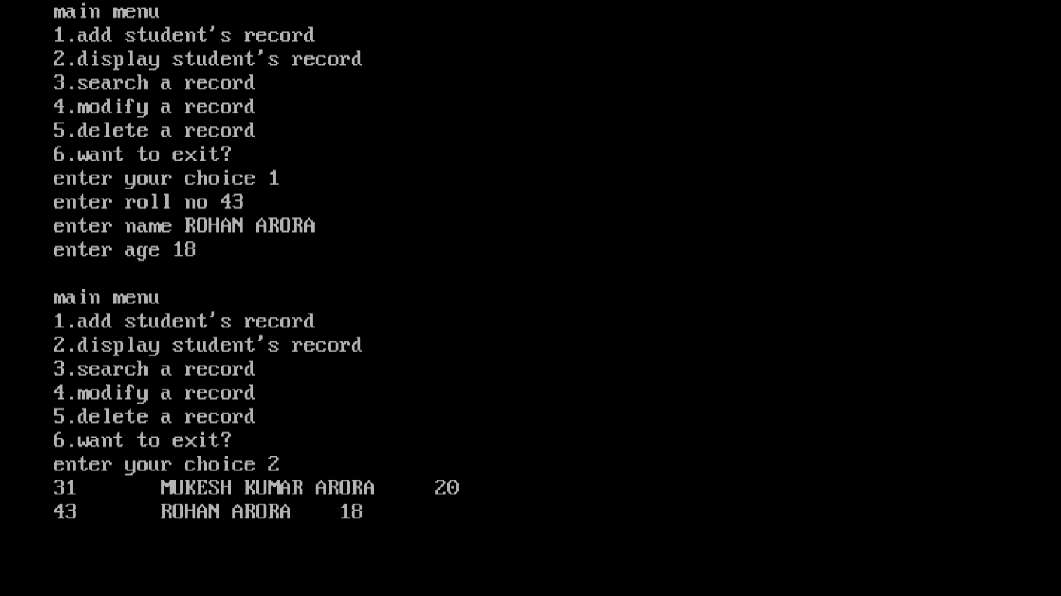

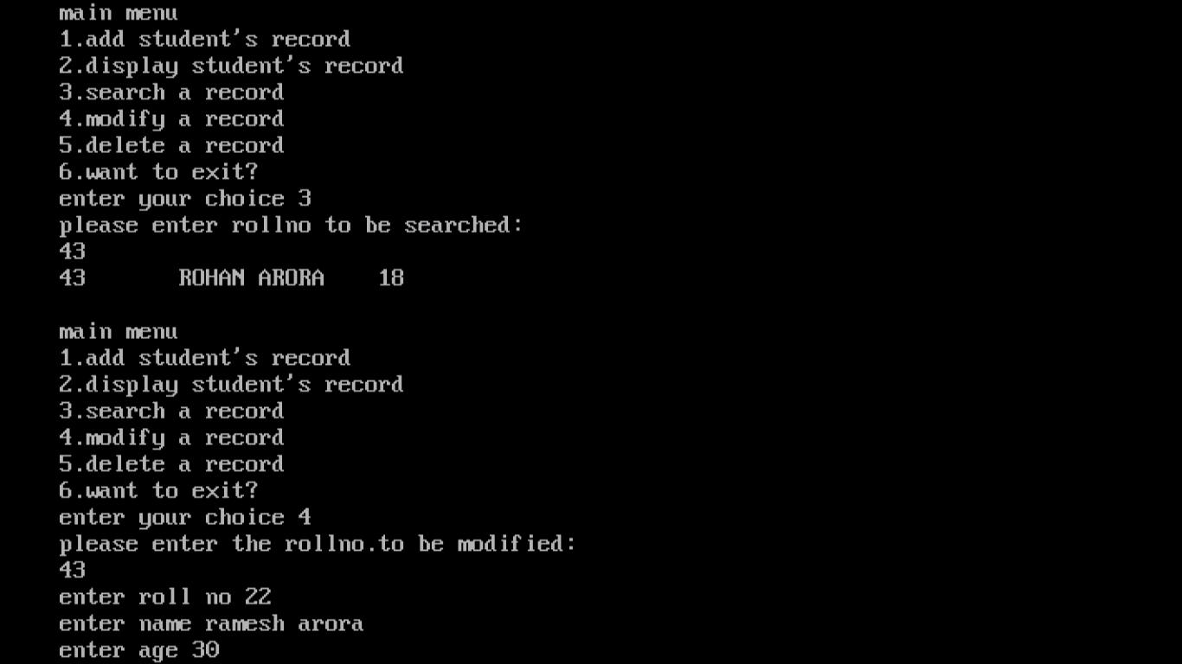

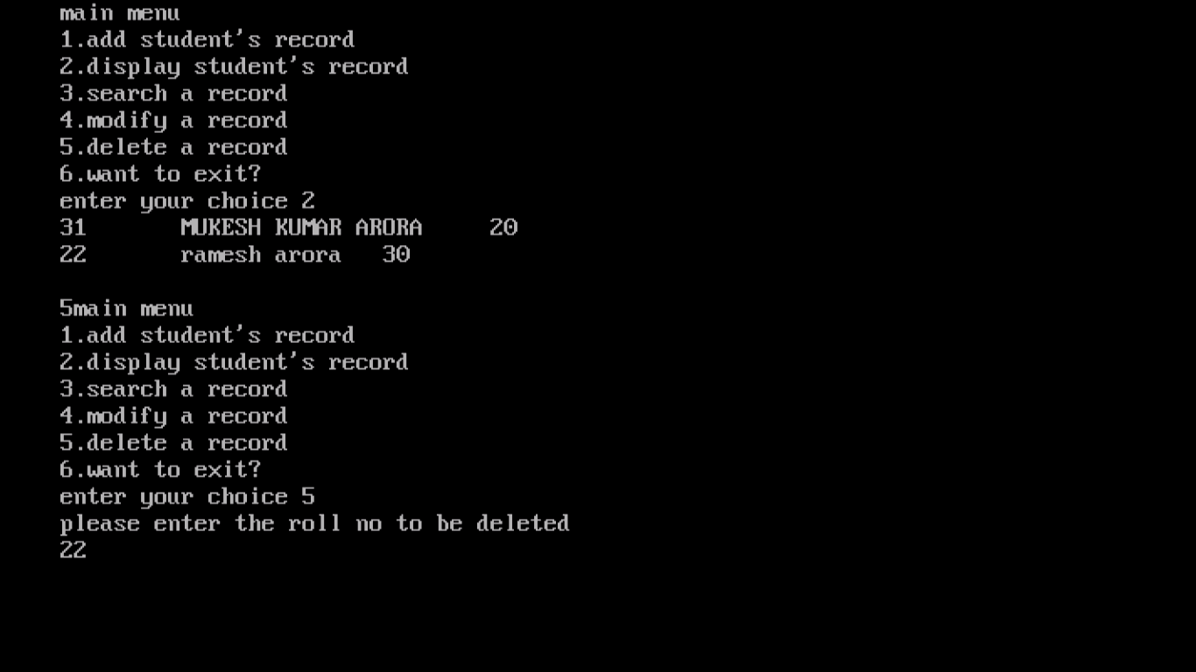

* **Menu driven 2:**

**#include<fstream.h>**

**#include<conio.h>**

**#include<stdio.h>**

**class employee**

**{**

**int code;**

**char name[20];**

**int salary;**

**public:**

**void getdata(void);**

**void putdata(void);**

**int getcode();**

**};**

**void employee::getdata()**

**{**

**cout<<"enter code";**

**cin>>code;**

**cout<<"enter name";**

**gets(name);**

**cout<<"enter salary";**

**cin>>salary;**

**}**

**void employee::putdata()**

**{**

**cout<<code<<"\t"<<name<<"\t"<<salary<<endl;**

**}**

**int employee::getcode()**

**{**

**return(code);**

**}**

**employee e;**

**void main()**

**{**

**clrscr();**

**void enterfile();**

**void displayfile();**

**void search();**

**void modify();**

**void Delete();**

**int c;**

**do**

**{**

**cout<<"main menu\n";**

**cout<<"1.add employee's record \n";**

**cout<<"2.display employee's record\n";**

**cout<<"3.search a record\n";**

**cout<<"4.modify a record\n";**

**cout<<"5.delete a record\n";**

**cout<<"6.want to exit?\n";**

**cout<<"enter your choice";**

**cin>>c;**

**switch(c)**

**{**

**case 1:enterfile();**

**break;**

**case 2:displayfile();**

**break;**

**case 3:search();**

**break;**

**case 4:modify();**

**break;**

**case 5:Delete();**

**break;**

**}**

**}while(c!=6);**

**cout<<endl;**

**getche();**

**}**

**void enterfile()**

**{**

**ofstream afile("emp.dat",ios::binary|ios::app );**

**e.getdata();**

**afile.write((char*)& e, sizeof(e));**

**afile.close();**

**cout<<endl;**

**getche();**

**}**

**void displayfile()**

**{**

**ifstream bfile("emp.dat",ios::binary);**

**while(bfile.read((char*)& e, sizeof(e)))**

**{**

**e.putdata();**

**}**

**bfile.close();**

**cout<<endl;**

**getche();**

**}**

**void search()**

**{**

**int p=-1,z;**

**ifstream cfile("emp.dat",ios::binary);**

**cout<<"please enter code to be searched:\n";**

**cin>>z;**

**while(cfile.read((char*)& e,sizeof(e)))**

**{**

**if(e.getcode()==z)**

**{**

**e.putdata();**

**p++;**

**}**

**}**

**if(p==-1)**

**cout<<"sorry!record not found\n";**

**cout<<endl;**

**cfile.close();**

**getche();**

**}**

**void modify()**

**{**

**int g=-1,a=0,t;**

**cout<<"please enter the code to be modified:\n";**

**cin>>t;**

**fstream dfile("emp.dat",ios::in|ios::binary|ios::out );**

**while(dfile.read((char*)& e,sizeof(e)))**

**{**

**a++;**

**if(e.getcode()==t)**

**{**

**e.getdata();**

**dfile.seekp((a-1)*sizeof(e),ios::beg);**

**dfile.write((char*)& e, sizeof(e));**

**g++;**

**}**

**}**

**if(g==-1)**

**cout<<"sorry record not found\n";**

**dfile.close();**

**getche();**

**}**

**void Delete()**

**{**

**int b;**

**ifstream efile("emp.dat",ios::binary);**

**ofstream ffile("temp.dat",ios::binary);**

**cout<<"please enter the code to be deleted\n";**

**cin>>b;**

**while(efile.read((char*)& e,sizeof(e)))**

**{**

**if(e.getcode()!=b)**

**{**

**ffile.write((char*)& e,sizeof(e));**

**}**

**}**

**remove("emp.dat");**

**rename("temp.dat","emp.dat");**

**efile.close();**

**ffile.close();**

**cout<<endl;**

**getche();**

**}**

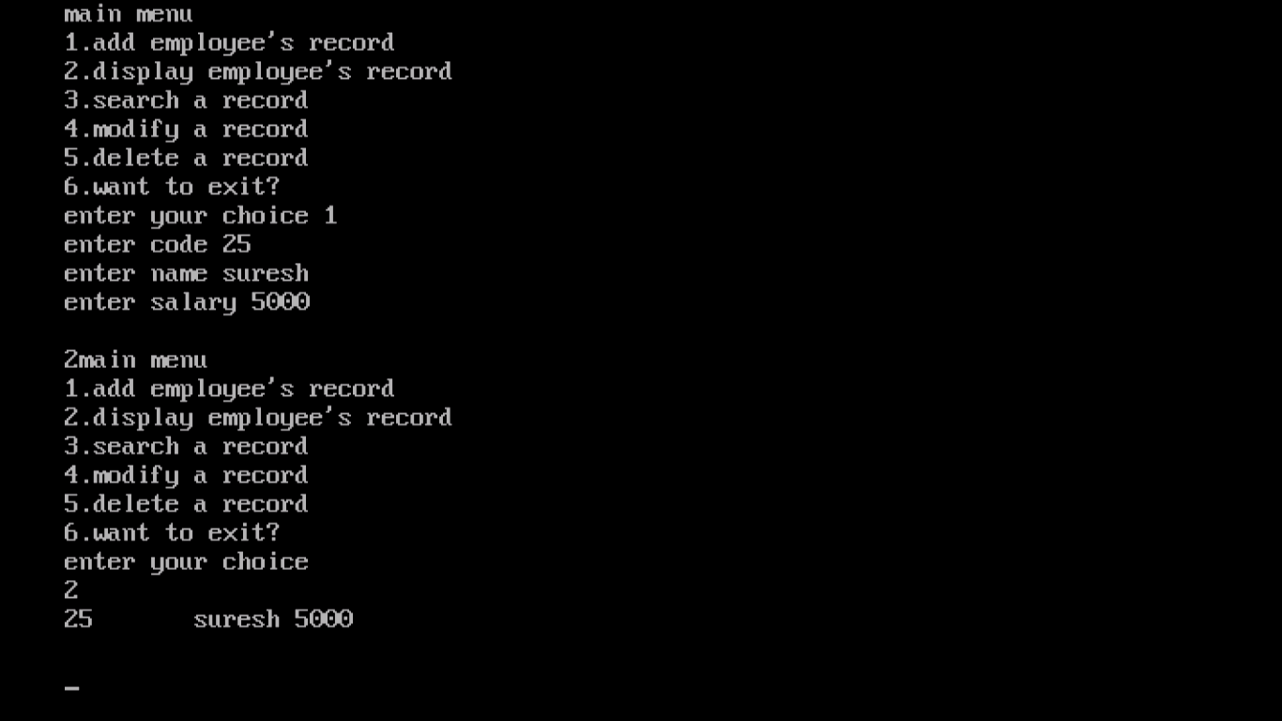

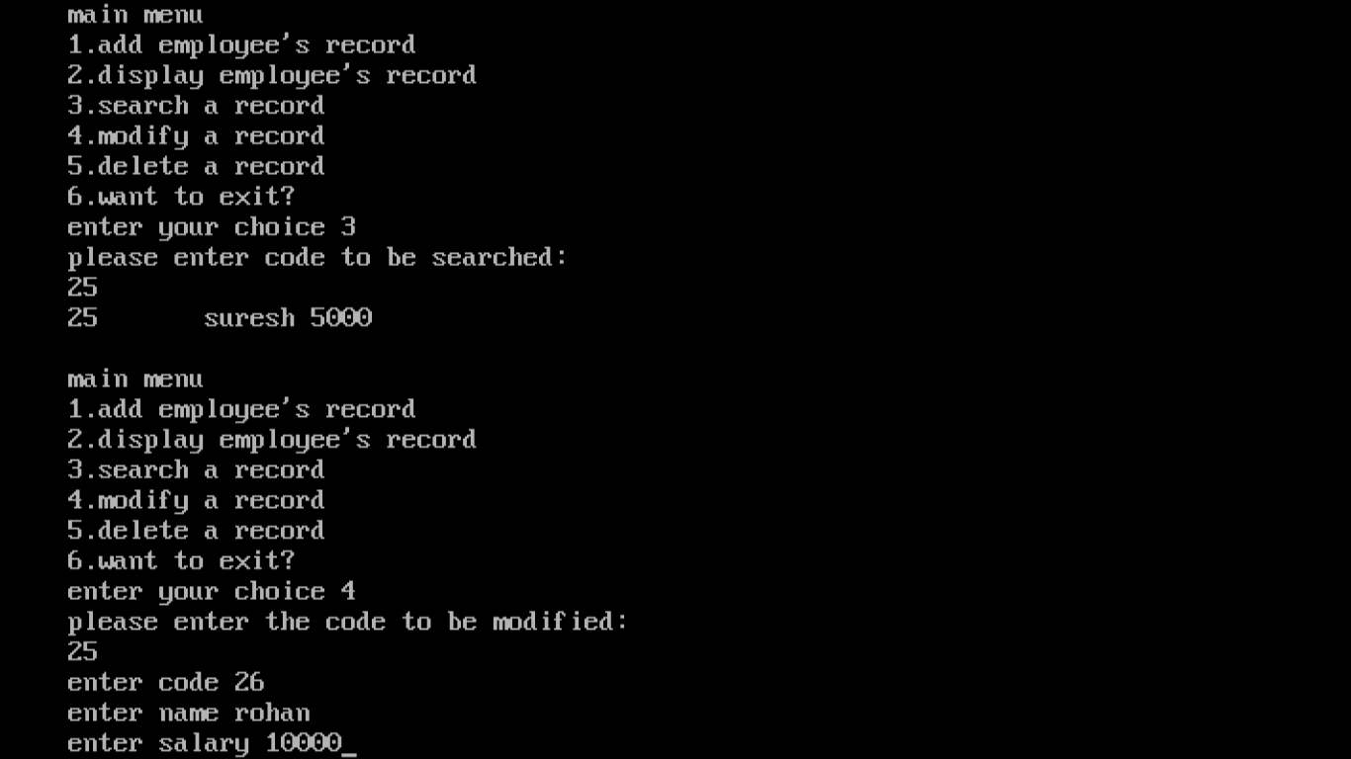

* **Linked list 1:**

**#include<iostream.h>**

**#include<conio.h>**

**class stack**

**{**

**int data[30];**

**int top;**

**int n;**

**public:**

**stack()**

**{**

**top=-1;**

**n=30;**

**}**

**void push();**

**int pop();**

**void display();**

**};**

**void stack::push()**

**{**

**int val;**

**cout<<"enter the value to be pushed";**

**cin>>val;**

**if(top<n)**

**{**

**top++;**

**data[top]=val;**

**}**

**else**

**{**

**cout<<"the stack is full\n";**

**}**

**}**

**int stack::pop()**

**{**

**int v;**

**if(top>=0)**

**{**

**v=data[top];**

**top--;**

**return(v);**

**}**

**else**

**{**

**cout<<"the stack is empty";**

**return(-9999);**

**}**

**}**

**void stack::display()**

**{**

**int i;**

**if(top>=0)**

**{**

**cout<<"\n";**

**for(i=top;i>=0;i--)**

**{**

**cout<<data[i]<<endl;**

**}**

**}**

**}**

**void main()**

**{**

**stack s;**

**int choice;**

**int v;**

**clrscr();**

**do**

**{**

**cout<<"\n main menu\n";**

**cout<<"\n 1.push";**

**cout<<"\n 2.pop";**

**cout<<"\n 3.display";**

**cout<<"\n 4.exit"<<endl;**

**cout<<"enter your choice";**

**cin>>choice;**

**switch(choice)**

**{**

**case 1:s.push();**

**break;**

**case 2:v=s.pop();**

**if(v!= -9999)**

**cout<<"\n the popped value is="<< v <<endl;**

**break;**

**case 3:s.display();**

**break;**

**}**

**}while(choice!=4);**

**getche();**

**}**

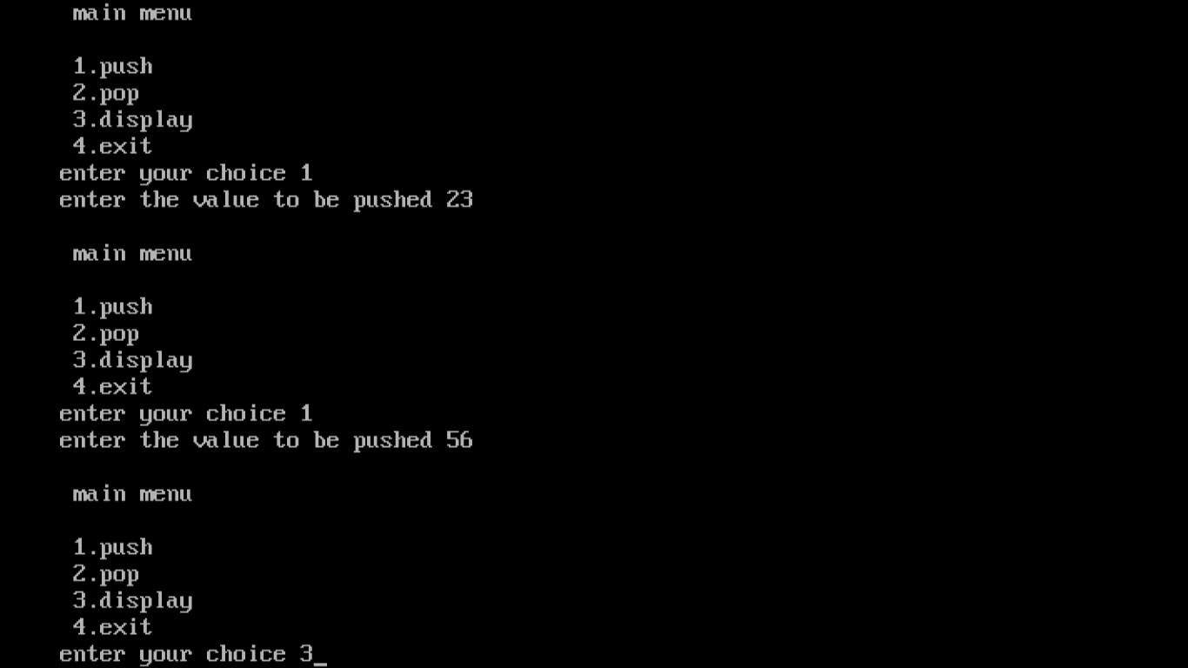

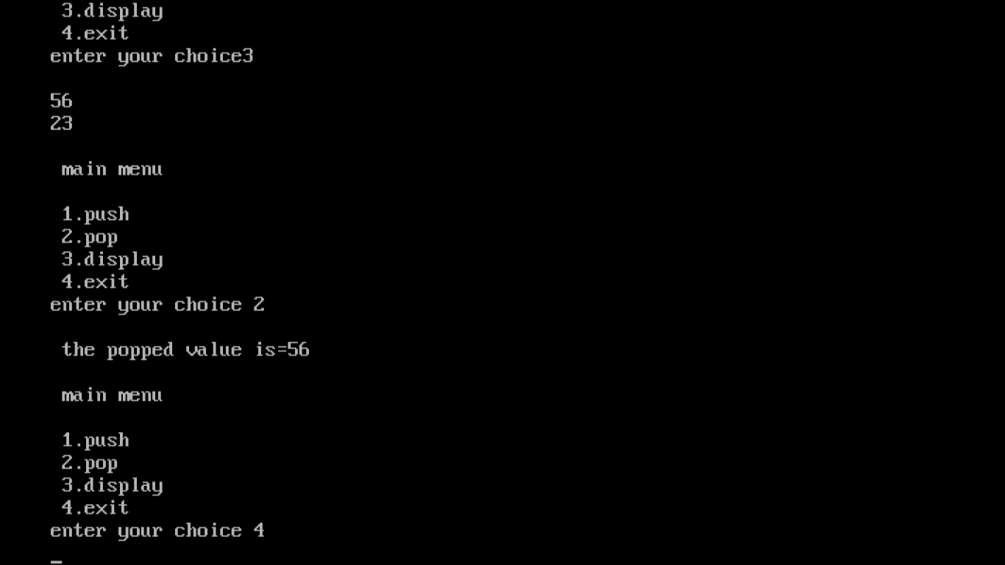

* **Linked list 2:**

**#include<iostream.h>**

**#include<conio.h>**

**#include<stdio.h>**

**#include<string.h>**

**class stack**

**{**

**char data[30][30];**

**int top;**

**int n;**

**public:**

**stack()**

**{**

**top=-1;**

**n=30;**

**}**

**void push();**

**char*pop();**

**void display();**

**};**

**void stack::push()**

**{**

**char val[30];**

**cout<<"enter the value to be pushed";**

**gets(val);**

**if(top<n)**

**{**

**top++;**

**strcpy(data[top],val);**

**}**

**else**

**{**

**cout<<"the stack is full\n";**

**}**

**}**

**char*stack::pop()**

**{**

**char v[30];**

**if(top>=0)**

**{**

**strcpy(v,data[top]);**

**top--;**

**return(v);**

**}**

**else**

**{**

**cout<<"the stack is empty";**

**return(NULL);**

**}**

**}**

**void stack::display()**

**{**

**int i;**

**if(top>=0)**

**{**

**cout<<"\n";**

**for(i=top;i>=0;i--)**

**{**

**cout<<data[i]<<endl;**

**}**

**}**

**}**

**void main()**

**{**

**stack s;**

**int choice;**

**char v[30];**

**clrscr();**

**do**

**{**

**cout<<"\n main menu\n";**

**cout<<"\n 1.push";**

**cout<<"\n 2.pop";**

**cout<<"\n 3.display";**

**cout<<"\n 4.exit"<<endl;**

**cout<<"enter your choice"<<endl;**

**cin>>choice;**

**switch(choice)**

**{**

**case 1:s.push();**

**break;**

**case 2:strcpy(v,s.pop());**

**if(strcmp(v,NULL)!=0)**

**cout<<"the poped value is"<<v<<endl;**

**break;**

**case 3:s.display();**

**break;**

**}**

**}while(choice!=4);**

**getche();**

**}**

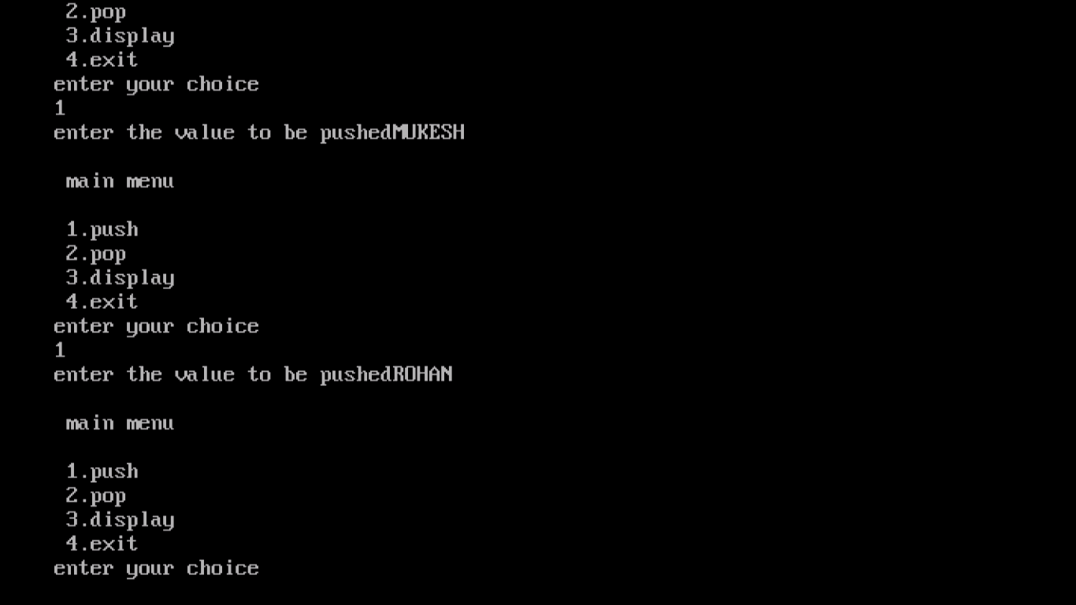

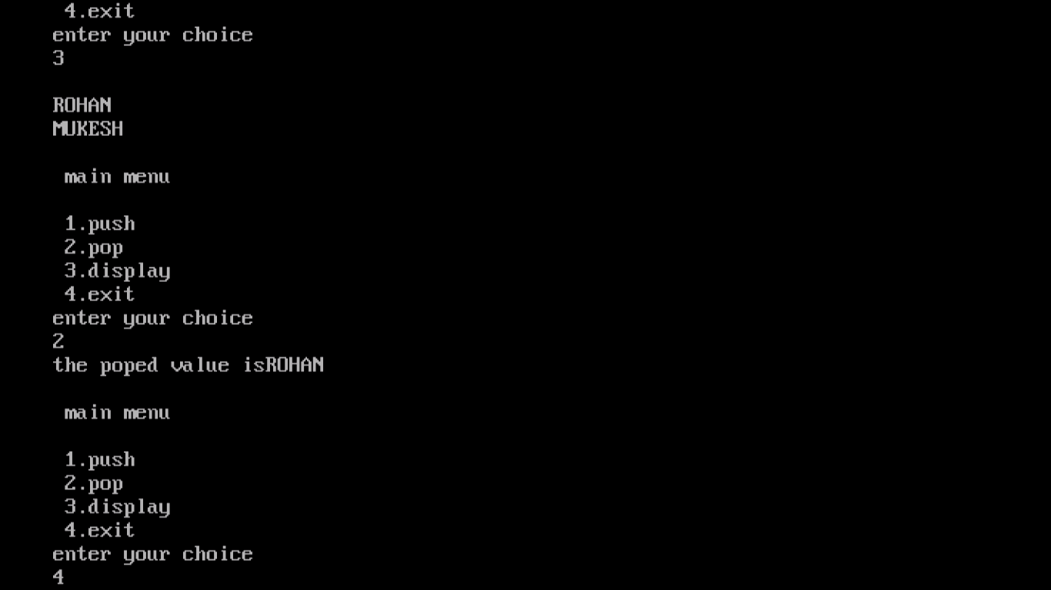

* **LINKED LIST 3:**

**#include<iostream.h>**

**#include<conio.h>**

**class queue**

**{**

**int data[30];**

**int front,rear;**

**int n;**

**public:**

**queue()**

**{**

**front=-1;**

**rear=-1;**

**n=29;**

**}**

**void add (int value,int size);**

**int remove();**

**void display();**

**};**

**void main()**

**{**

**clrscr();**

**queue q;**

**int choice,val,size;**

**cout<<"\n enter size";**

**cin>>size;**

**do**

**{**

**cout<<"\n main menu\n";**

**cout<<"1.add\n";**

**cout<<"2.remove\n";**

**cout<<"3.display\n";**

**cout<<"4.exit\n";**

**cin>>choice;**

**switch(choice)**

**{**

**case 1:cout<<"\n enter val";**

**cin>>val;**

**q.add(val,size);**

**break;**

**case 2:int n=q.remove();**

**if (n!=-9999)**

**cout<<"removed:"<<n;**

**break;**

**case 3:q.display();**

**break;**

**}**

**}while(choice!=4);**

**getche();**

**}**

**void queue::add(int val,int size)**

**{**

**if(rear<size)**

**{**

**rear++;**

**data[rear]=val;**

**}**

**else**

**{**

**cout<<"\n overflow";**

**}**

**}**

**int queue::remove()**

**{**

**if(front<=rear)**

**{**

**return data[++ front];**

**}**

**else**

**{**

**cout<<"\n underflow";**

**return(-9999);**

**}**

**}**

**void queue::display()**

**{**

**int i;**

**for(i=front+1;i<=rear;i++)**

**{**

**cout<<data[i]<<endl;**

**}**

**}**

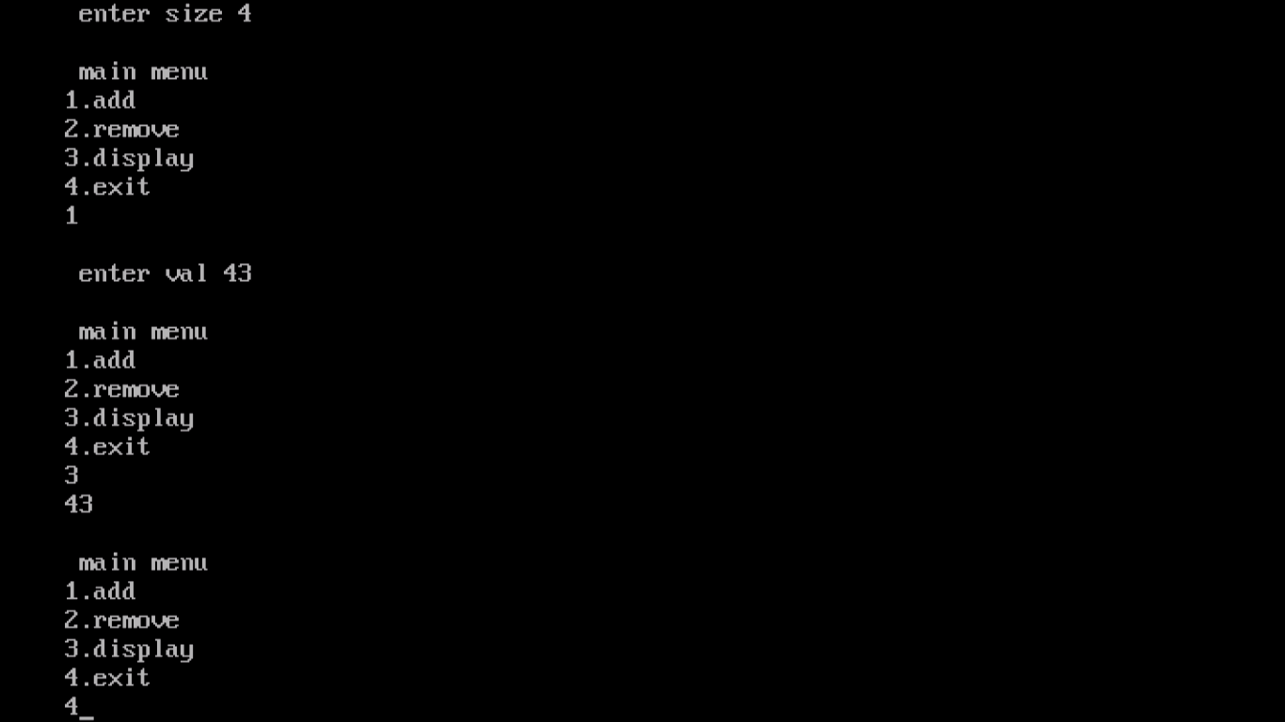

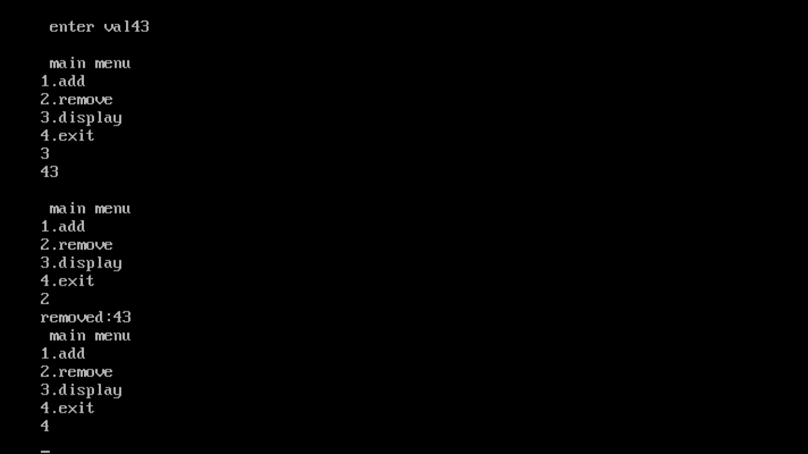

* **Linked list 4:**

**#include<iostream.h>**

**#include<conio.h>**

**#include<stdio.h>**

**#include<string.h>**

**class queue**

**{**

**char data[30][30];**

**int front,rear;**

**int n;**

**public:**

**queue()**

**{**

**front=-1;**

**rear=-1;**

**n=29;**

**}**

**void add(char val[30],int size);**

**char*remove();**

**void display();**

**};**

**void main()**

**{**

**clrscr();**

**queue q;**

**int choice;**

**char val[30];**

**int size;**

**cout<<"\n enter size";**

**cin>>size;**

**do**

**{**

**cout<<"\n main menu\n";**

**cout<<"1. add";**

**cout<<"2. remove";**

**cout<<"3. display";**

**cout<<"4. want to exit?";**

**cout<<"enter your selection";**

**cin>>choice;**

**switch(choice)**

**{**

**case 1: cout<<"\n enter val";**

**gets(val);**

**q.add(val,size);**

**break;**

**case 2: char x[30];**

**strcpy(x,q.remove());**

**if (strcmp(x,NULL)!=0)**

**cout<<"remove:"<<x;**

**break;**

**case 3: q.display();**

**break;**

**}**

**}while(choice!=4);**

**getche();**

**}**

**void queue::add(char val[30],int size)**

**{**

**if(rear<size)**

**{**

**rear++;**

**strcpy(data[rear],val);**

**}**

**else**

**{**

**cout<<"\n overflow";**

**}**

**}**

**char*queue::remove()**

**{**

**if (front<=rear)**

**{**

**return data[++front];**

**}**

**else**

**{**

**cout<<"\n underflow";**

**return(NULL);**

**}**

**}**

**void queue::display()**

**{**

**for(int i=front+1;i<=rear;i++)**

**{**

**cout<<data[i]<<endl;**

**}**

**}**

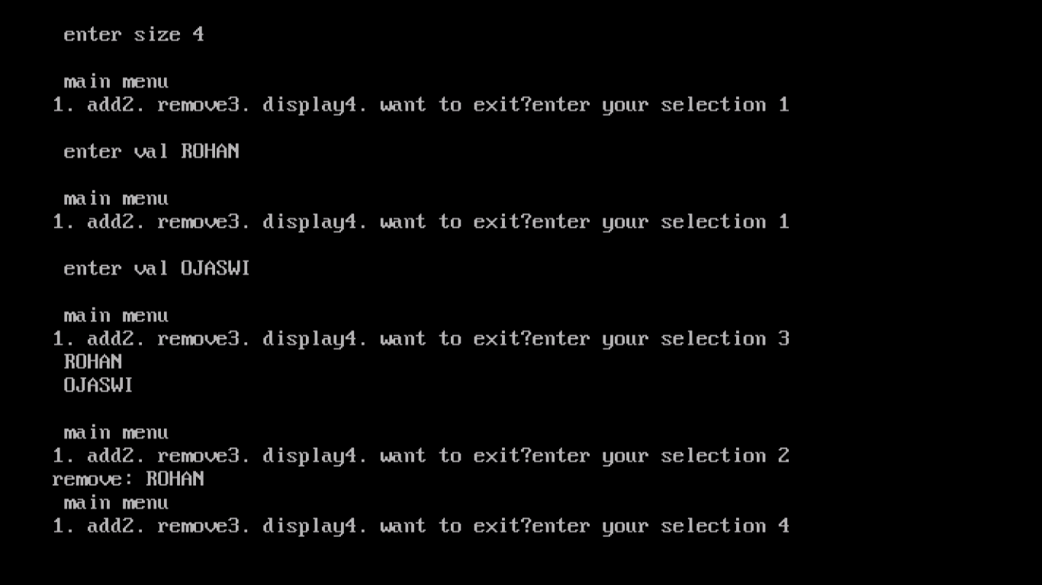

* **Linked list 5:**

**#include<iostream.h>**

**#include<conio.h>**

**struct node**

**{**

**int data;**

**node*next;**

**};**

**node*push(node*top,int val);**

**node*pop(node*top,int & val);**

**void showstack(node*top);**

**void main()**

**{**

**int choice;**

**int val;**

**node*top;**

**top=NULL;**

**clrscr();**

**do**

**{**

**cout<<"\n main menu";**

**cout<<"1. push";**

**cout<<"2. pop";**

**cout<<"3. show";**

**cout<<"4. exit";**

**cout<<" enter your choice";**

**cin>>choice;**

**switch(choice)**

**{**

**case 1: cout<<"enter value to be added"<<endl;**

**cin>>val;**

**top=push(top,val);**

**break;**

**case 2: top=pop(top,val);**

**if(val!=-9999)**

**cout<<"the poped value is"<<val<<endl;**

**break;**

**case 3: showstack(top);**

**break;**

**}**

**}while (choice!=4);**

**getche();**

**}**

**node*push(node*top,int val)**

**{**

**node*x;**

**x=new node;**

**x-> data=val;**

**x-> next=top;**

**top=x;**

**return(top);**

**}**

**node*pop(node*top,int & val)**

**{**

**node*x;**

**if(top==NULL)**

**{**

**cout<<"\n the stack is empty";**

**return(top);**

**}**

**else**

**{**

**x=top;**

**top=top-> next;**

**val=x-> data;**

**delete x;**

**}**

**return (top);**

**}**

**void showstack (node*top)**

**{**

**node*ptr;**

**ptr=top;**

**while(ptr!=NULL)**

**{**

**cout<<ptr-> data<< endl;**

**ptr=ptr->next;**

**}**

**}**

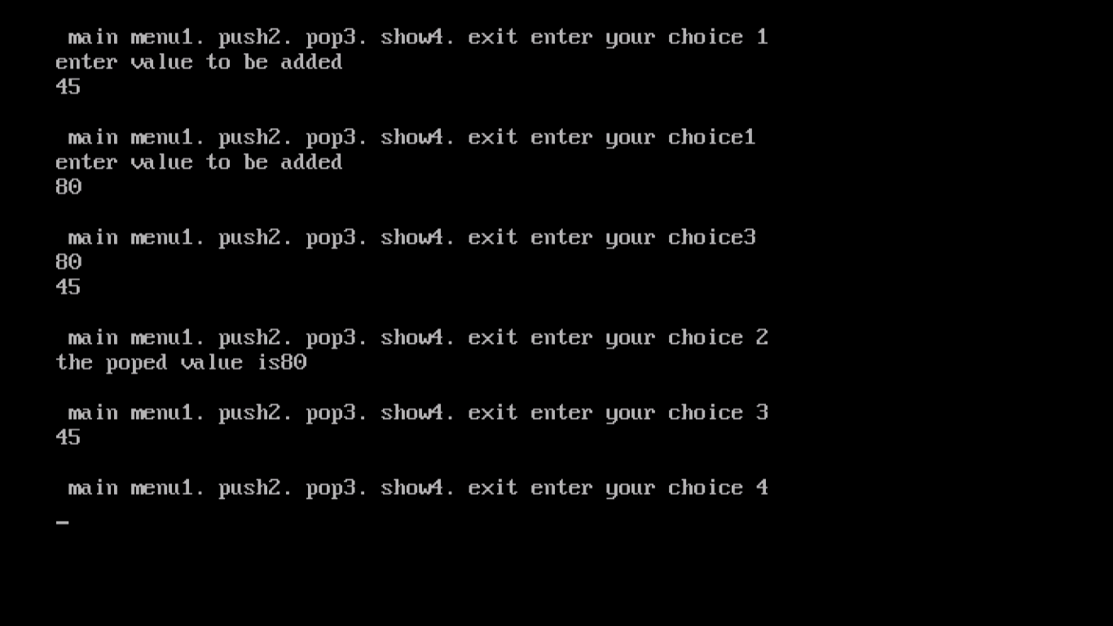

* **Linked list 6:**

**#include<iostream.h>**

**#include<conio.h>**

**#include<string.h>**

**struct node**

**{**

**char data[20];**

**node*next;**

**};**

**node*push(node*top,char val[20]);**

**node*pop(node*top,char val[20]);**

**void showstack(node*top);**

**void main()**

**{**

**int choice;**

**node*top;**

**top=NULL;**

**char val[20];**

**clrscr();**

**do**

**{**

**cout<<"\n main menu";**

**cout<<"1. push";**

**cout<<"2. pop";**

**cout<<"3. show";**

**cout<<"4. exit";**

**cout<<" enter your choice";**

**cin>>choice;**

**switch(choice)**

**{**

**case 1: cout<<"enter value to be added"<<endl;**

**cin>>val;**

**top=push(top,val);**

**break;**

**case 2: top=pop(top,val);**

**if(strcmp(val,NULL)!=0)**

**cout<<"the deleted value is"<<val<<endl;**

**break;**

**case 3: showstack(top);**

**break;**

**}**

**}while (choice!=4);**

**getche();**

**}**

**node*push(node*top,char val[20])**

**{**

**node*x;**

**x=new node;**

**strcpy(x->data,val);**

**x-> next=top;**

**top=x;**

**return(top);**

**}**

**node*pop(node*top,char val[20])**

**{**

**node*x;**

**if(top==NULL)**

**{**

**cout<<"\n the stack is empty";**

**strcpy(val,NULL);**

**}**

**else**

**{**

**x=top;**

**top=top-> next;**

**strcpy(val,x-> data);**

**delete x;**

**}**

**return (top);**

**}**

**void showstack (node*top)**

**{**

**node*ptr;**

**ptr=top;**

**while(ptr!=NULL)**

**{**

**cout<<ptr-> data<< endl;**

**ptr=ptr->next;**

**}**

**}**

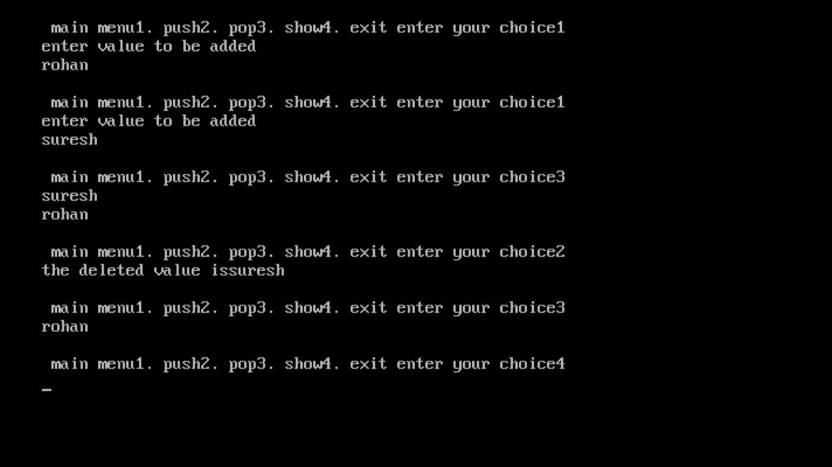

* **Linked list 7:**

**#include<iostream.h>**

**#include<conio.h>**

**#include<stdio.h>**

**#include<string.h>**

**struct student**

**{**

**int rollno;**

**char name[20];**

**student*next;**

**};**

**student*push(student*top,int r,char n[20]);**

**student*pop(student*top,int & r,char n[20]);**

**void showstack(student*top);**

**void main()**

**{**

**int choice;**

**student*top;**

**top=NULL;**

**int r;**

**char n[20];**

**clrscr();**

**do**

**{**

**cout<<" \n Main menu"<<endl;**

**cout<<"1.push"<<endl;**

**cout<<"2.pop"<<endl;**

**cout<<"3.show"<<endl;**

**cout<<"4.exit"<<endl;**

**cout<<"enter your choice "<<endl;**

**cin>>choice;**

**switch(choice)**

**{**

**case 1:cout<<"enter rollno";**

**cin>>r;**

**cout<<"enter name";**

**gets(n);**

**top=push(top,r,n);**

**break;**

**case 2:top=pop(top,r,n);**

**if(strcmp(n,NULL)!=0)**

**cout<<"the deleted value is"<<r<<n<<endl;**

**break;**

**case 3:showstack(top);**

**break;**

**}**

**}while (choice!=4);**

**getche();**

**}**

**student*push(student*top,int r,char n[20])**

**{**

**student*x;**

**x=new student;**

**x->rollno=r;**

**strcpy(x->name,n);**

**x->next=top;**

**top=x;**

**return(top);**

**}**

**student*pop(student*top,int & r,char n[20])**

**{**

**student*x;**

**if(top==NULL)**

**{**

**cout<<"stack is empty"<<endl;**

**strcpy(n,NULL);**

**}**

**else**

**{**

**x=top;**

**top=top->next;**

**r=x->rollno;**

**strcpy(n,x->name);**

**delete x;**

**}**

**return(top);**

**}**

**void showstack(student*top)**

**{**

**student*ptr;**

**ptr=top;**

**while(ptr!=NULL)**

**{**

**cout<<ptr->rollno <<"\t"<<ptr->name<<endl;**

**ptr=ptr->next;**

**}**

**}**

